Pitch of bird call?  (soprano, alto, tenor, bass) | Color of feathers, or volume of call? (Forte or piano) | Length of call?  (legato or staccato) | Melody?  (trills, chirps, quacks, clucks, hoots, tweets, whistles, caws, or shrieks) | Name of bird found:
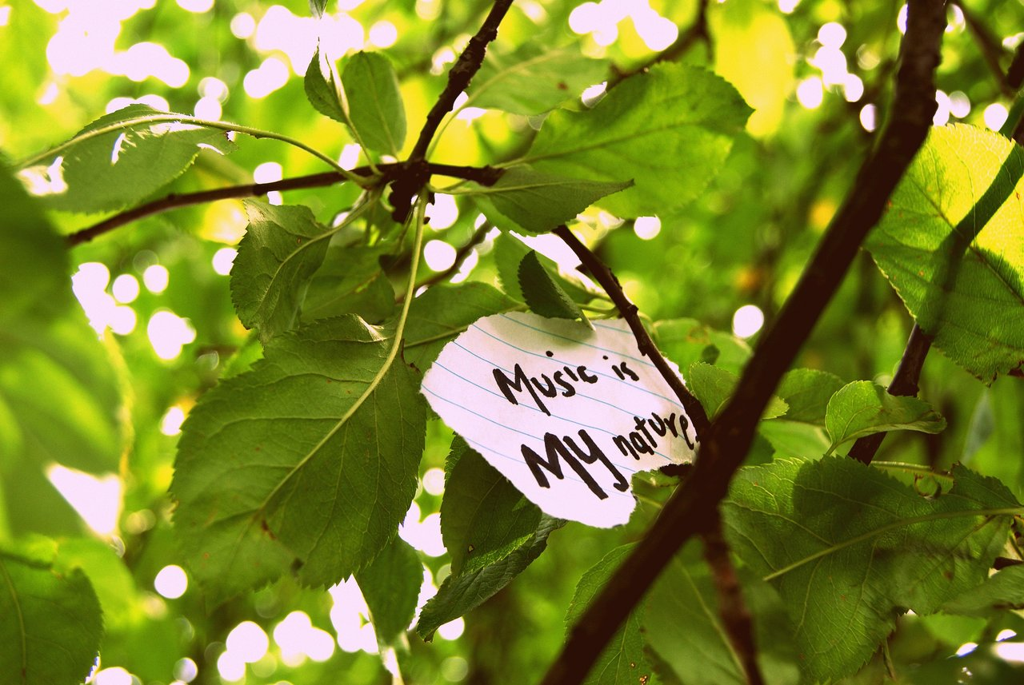
Name:_________________________________________ Date:____________________
Find five species to identify!
Fill out each box with the correct information. Turn it in when we reenter the building.
Translating Climate Change Into Music: Day 2
BOG WALK SOUND MAP

Classroom Teacher:_____________________________________________________

