Flower, plant, or tree? | Color of petals leaf, or needle | Shape of petals or leaf (draw) | Does it have a smell? Describe it! | Name of species found:
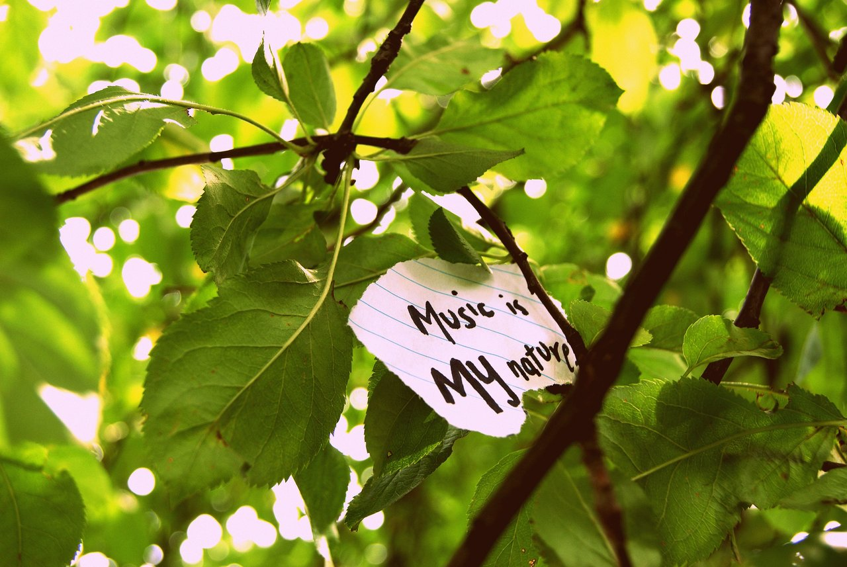
Name:_______________________________________ Date:_________________________
Translating Climate Change Into Music: Day 2
BOG WALK SIGHT MAP

Classroom Teacher:________________________________________________________
Find five species to identify!
Fill out each box with the correct information. Turn it in when we reenter the building.

