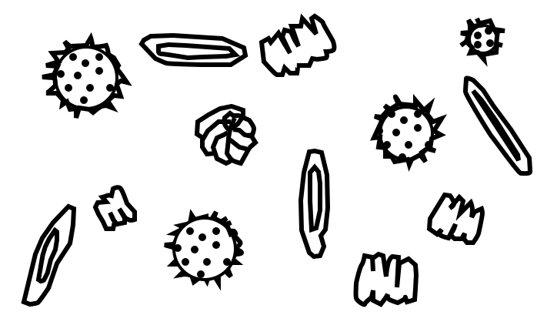  PLANKTON | 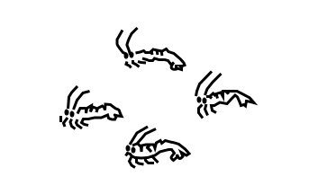  KRILL
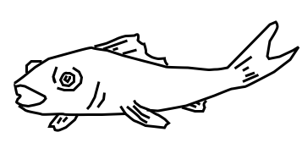  FISH | 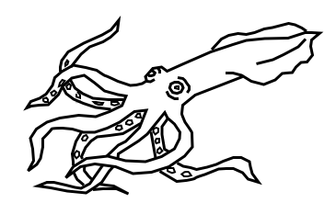  SQUID
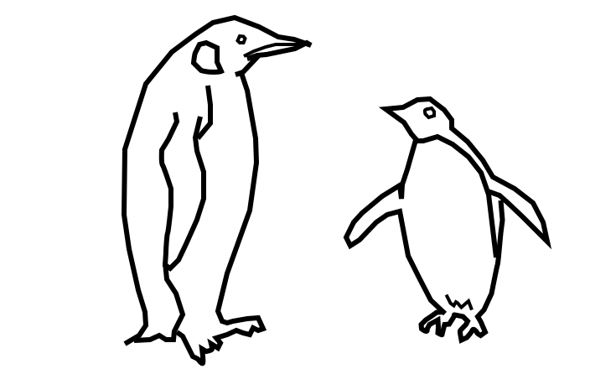  PENGUINS | 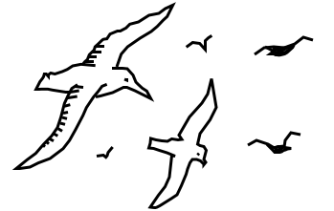  SEA BIRDS
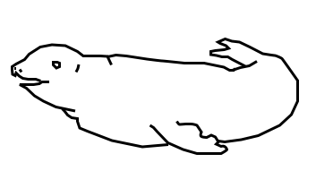  CRABEATER SEAL | 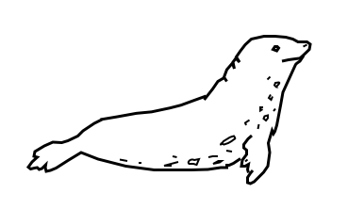  LEOPARD SEALS

- Small (1cm to 15cm) red, shrimp-like creatures.  - Looks like a crayfish without the front claws.  - Provides food source for most of the other life forms.  - Sometimes found in groups called swarms. | - Phytoplankton are speck-sized plants that are the major producers of the Antarctic  - Zooplankton are microscopic animals, who along with the phytoplankton, make up a group of animals called plankton  - Algae are very small plants found free-floating in the Antarctic waters  - Plankton and algae are the base for the Antarctic food pyramid.
- There are many species (30-40) found in Antarctic waters.  - Sometimes found in groups called shoals.  - Is a food source for many larger animals.  - Feeds on small fish and krill. | - There are about 100 species of fish found in the waters off Antarctica.  - Very small fish may feed on the plankton and algae.  - Most feed on krill and on each other.
- A large variety of birds visit the Antarctic region.  - The Skua is a scavenger, feeding on eggs and young penguins and wounded or dead animals.  - Many of the seabirds also feed on fish, squid, and krill. | - A flightless bird, "wings" adapted to be effective paddles for swimming.  - Only large animals to inhabit the Antarctic mainland during winter (Emperor).  - Have no predators on land.  - Feed on fish and krill.  - Is preyed on by leopard seals and killer whales.  - Six types are found in Antarctica including the Emperor and Adelie.
- Is preyed upon by the killer whale.  - Feeds on penguins, young crabeater seals, fish, squid, krill. | - Is preyed upon by killer whales, and when young, leopard seals.  - Feeds on krill not crabs; has unusual teeth which are effective strainers.  - Is the most abundant seal in the world.

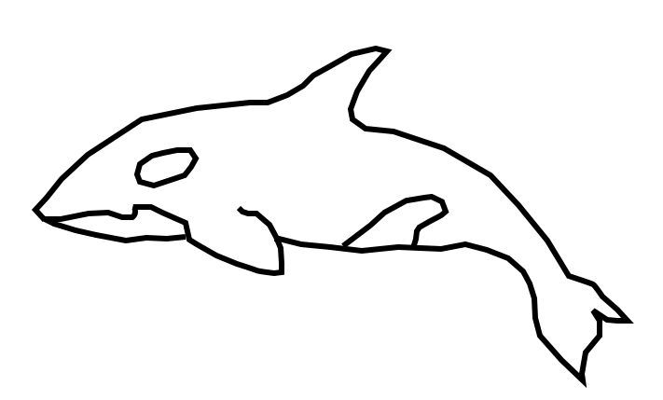  KILLER WHALE | 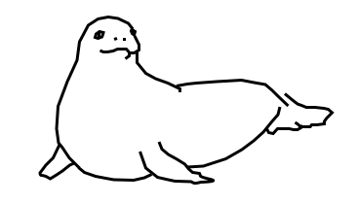WEDDELL SEAL
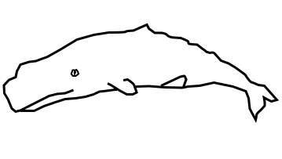  SPERM WHALE | 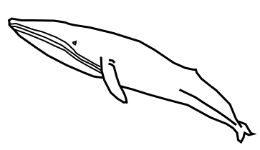  BLUE WHALE
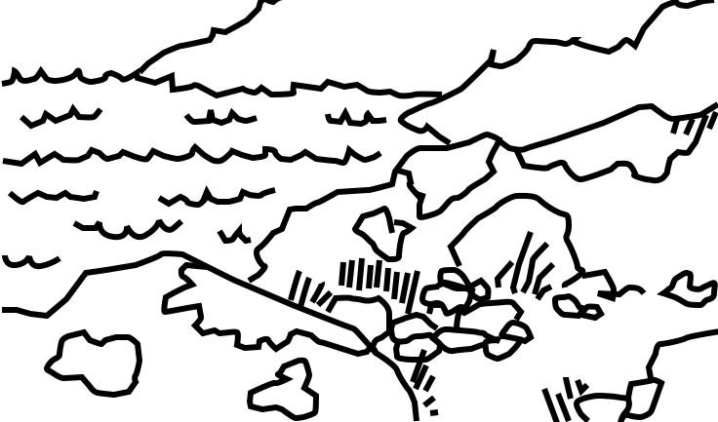
LIFE ON LAND

- It feeds mostly on cod and silverfish.  - Is preyed upon by killer whales and when young, leopard seals.  - Is at times killed by man because it's found close to many of the Antarctic bases (killed to feed sled dogs).  - Very deep diver, can stay submerged for up to an hour and a half. | - Top carnivore of the Antarctic  - Travels in packs or family groups called pods.  - Feeds on seals, penguins, fish, and occasionally other whales
- Largest animal found on earth.  - Feeds on krill which it strains through its baleen.  - Only natural predator is the killer whale.  - Man has killed so many that it has brought them close to extinction | - Is a toothed whale.  - Feeds on fish and squid.  - Is occasionally preyed upon by the killer whale.  - Deep diver, using echolocation to find prey in dark deep waters.
- The only plant life found on Antarctica is sparse growth of mosses, lichen, fungi, and fresh-water algae.
- Plant life survives on exposed patches of ground during the summer.
- Bacteria and fungi are the main decomposers.
- The largest group of animals is insects (mites and ticks).

