Franklin Academy Graduate Headed to Greenland To Study Shrinking Ice Caps

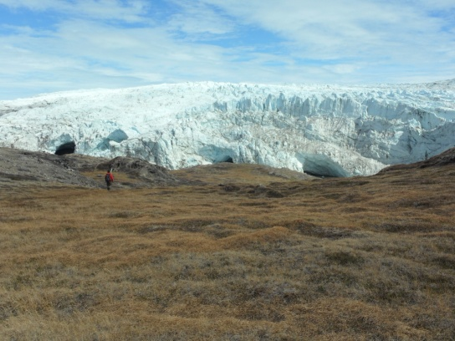
Class of 1986 Franklin Academy graduate, Tina McMahon Ciarametaro i s headed to western Greenland in August as part of Dr. Briner's research team. Dr. Briner, associate professor of Geology at SUNY Buffalo, is trying to reconstruct glacier responses to past climate events in recent Earth history. Dr. Briner believes that, "identifying the current degree of glacier retreat and its significance in the longer-term context of glacier history encourages a deeper understanding of what it means for society."
Photo 1: Tina McMahon Ciarametaro
The research team will apply techniques to both the preserved plants and rocks currently being exposed at the foot of retreating glaciers in West Greenland. The data obtained from these complimentary techniques will explicitly date when the region was last as warm as present. Climate reconstructions with on-going studies elsewhere will help to further define recent abrupt climate changes.
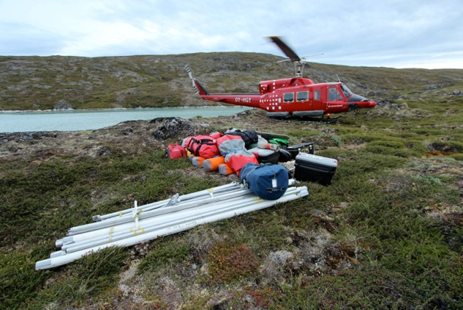
The research team will spend 18 days in the field camping near the retreating glaciers. Tina and the team will relocate their camp three times by way of helicopter. Helicopters will be used to access glaciers not accessible by foot. Tina spent a week this past February, in Fairbanks, Alaska training for this expedition and she participated in an Arctic Survival Course in March.
Photo 2: by Jim Pottinger (PolarTREC 2011), Courtesy of ARCUS
Tina was matched with Dr. Briner's research through the PolarTREC program. PolarTREC matches K-12 teachers with polar researchers to spend three to six weeks participating in field research experiences in the polar regions. PolarTREC's goal is to invigorate polar science education and understanding by bringing K-12 educators and researchers together. One of PolarTREC's main objectives is, "to develop long-term professional relationships between teachers and researchers and to develop researcher understanding of K-12 education to strengthen outreach and dissemination of their research." Upon completion of the expedition, Tina will implement her experience within her classroom and share her experiences in different venues.
Photo 3: by Dr. Jason Briner, July 2013
Tina will be posting journal entries daily via a satellite phone. You can follow her expedition and post questions at: http://www.polartrec.com/expeditions/shrinking-arctic-icecaps
or scan the following qr code:

