Lesson: Is Greenland Really That Big?
Mark Buesing
PolarTREC 2013

Background/Overview:
NASA's Operation IceBridge images Earth's polar ice in unprecedented detail to better understand processes that connect the Polar Regions with the global climate system. IceBridge uses a specialized fleet of aircraft and the most sophisticated suite of science instruments ever assembled to gather data on sea ice, glaciers, and ice sheets. The data gathered today will allow future scientists to better understand and model climate change. It is no exaggeration to say that teachers, those who work in support of teachers, and parents are literally raising the next generation of scientists for whom this data will be critical.
http://www.nasa.gov/mission_pages/icebridge/index.html

One of the places Operation IceBridge gathers data is Greenland, an autonomous country within the Kingdom of Denmark. This lesson/activity starts with figuring the area of an irregular figure – Greenland. From there the lesson can be extended to different map projections, comparisons, cartography, limits, and history.

Subject: Math, Geography, Earth Science, and Cartography

Grade Level: 9-12

Learning Objectives:
- Estimate the area of an irregular figure
- Compare geometric areas
- Understand map projections
- Understand the importance of a 3D model

Mathematics CCSS:
HSG-GMD.B.4 Identify the shapes of two-dimensional cross-sections of three-dimensional objects, and identify three-dimensional objects generated by rotations of two-dimensional objects.

HSG-MG.A.3 Apply geometric methods to solve design problems (e.g., designing an object or structure to satisfy physical constraints or minimize cost; working with typographic grid systems based on ratios).

HSN-Q.A.3 Choose a level of accuracy appropriate to limitations on measurement when reporting quantities.
G-MG.1 Use geometric shapes, their measures, and their properties to describe objects (e.g., modeling a tree trunk or a human torso as a cylinder).

8.EE.3 Use numbers expressed in the form of a single digit times an integer power of 10 to estimate very large or very small quantities, and to express how many times as much one is than the other. For example, estimate the population of the United States as 3x10⁸ and the population of the world as 7x10⁹, and determine that the world population is more than 20 times larger.

Plan:
As an introduction watch the video “Is Greenland Really THAT big?”
http://youtu.be/hJWGCzdUPPI

Part 1: Use the figure below to estimate the area of Greenland. Each square represents 8,600 square kilometers. First discuss with a partner how you are going to do this.
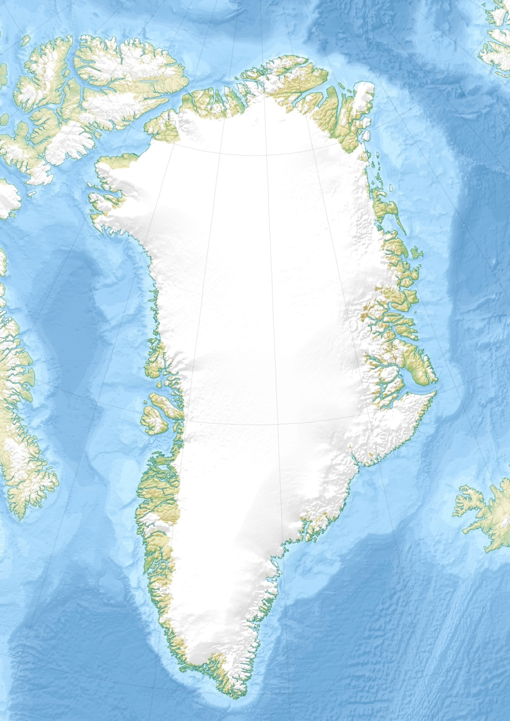

Questions:
- What did you figure for the area of Greenland?
- Is your partner’s estimate close to yours? If not, why not? Work together until you agree on an area.
- Would larger or smaller squares make the estimate more accurate? Explain.
- How small would you want the squares in order to get the most accurate estimate?
- Is there a limit as to how small the squares could be? Explain.
- Give two reasons why it someone would want to know the area of an island.
Go over these answers before moving on:
- 2,166,000 square kilometers. How many estimates were over this value? How many were under this value? Does the shape of an irregular figure make a difference as to how close an estimate is to the actual value?
- Answers will vary
- Smaller squares would make the estimate more accurate because more squares would be completely filled thereby reducing the area where estimates need to be made.
- As small as possible or as small as can be seen.
- Answers will vary, but this may be a good time to talk about the Area Postulate, limits, or numerical integration.
- Answers will vary. To determine infrastructure needs, to sell land, to develop the land for industrial purposes, to calculate quantities of resources, to determine what fraction is not covered by ice (specific to Greenland)

MERCATOR PROJECTION (lines of latitude and longitude form right angles):
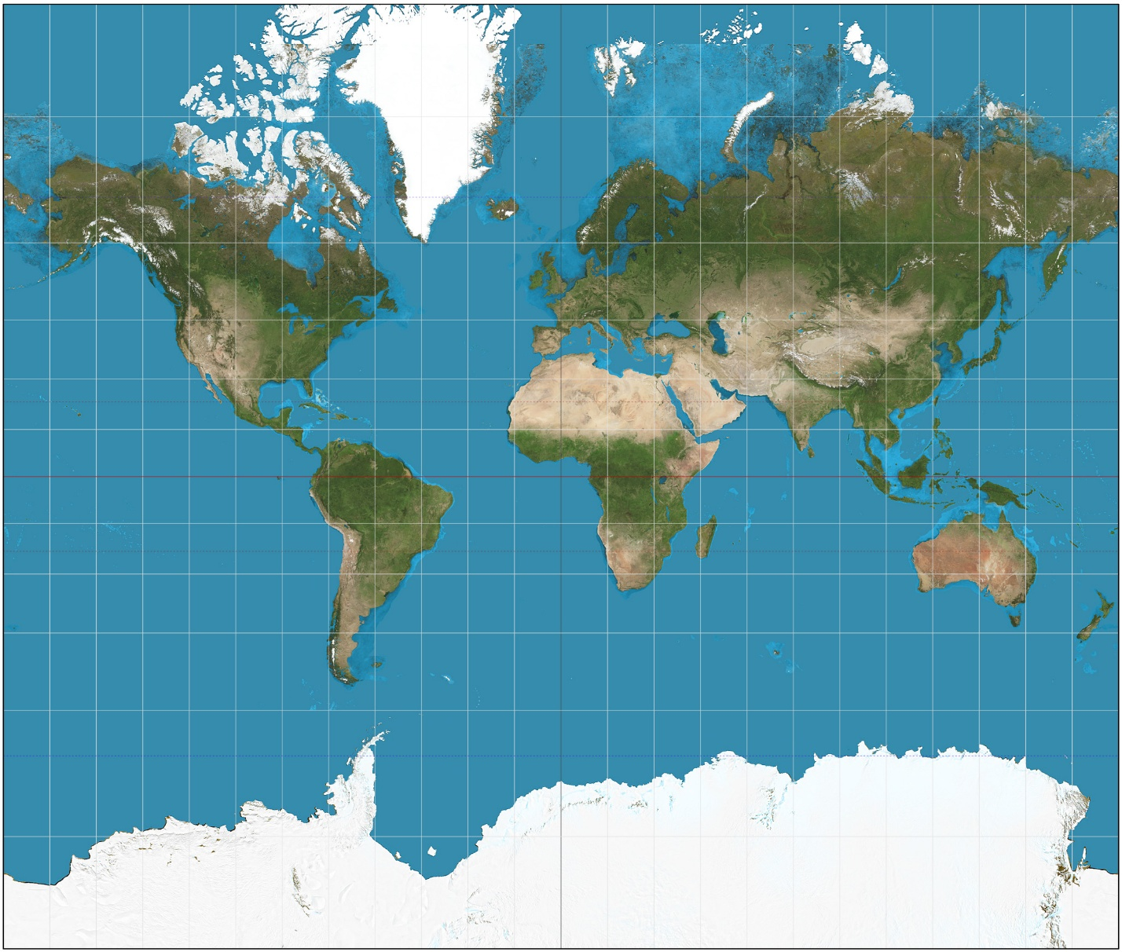
Starting with the Mercator projection trace Greenland onto a piece of paper and cut it out, like in the video.

Questions:
- Compare Greenland to other land areas. List at least two areas that are about the same as Greenland.
- Google the areas you are comparing and record them.
- Based on the actual area of Greenland given by your teacher, are you close? By what factor are you in error? (For example, if you thought you had an area of 100 and the actual area was 20, you are in error by a factor of 5.)
- Does the Mercator projection better represent the true area of polar or equatorial regions? (Hint: look closely at the spacing of the lines of latitude and longitude on the map.)
- If the Mercator projection is so inaccurate, why is it used?

Answers:
- South America, Africa, most of North America, Russia, and many others
- South America = 18 million sq km, Africa = 30 million sq km, North America (minus Alaska) = 23 million sq km, Russia = 17 million sq km
- 7 – 14
- Equitorial regions - the lines of longitude are parallel on a Mercator projection (they converge at the poles) and lines of latitude get progrssively further apart (they are evenly spaced on the earth – ignoring the equitorial bulge)
- It was very useful in navigation as it preserved angles. Straight lines on a Mercator projection are lines of constant heading or direction. In the days of navigating by stars, sun, and compass, this was useful. Today it is rarely used.

ROBINSON PROJECTION (lines of latitude are horizontal and lines of longitude are curved more and more):
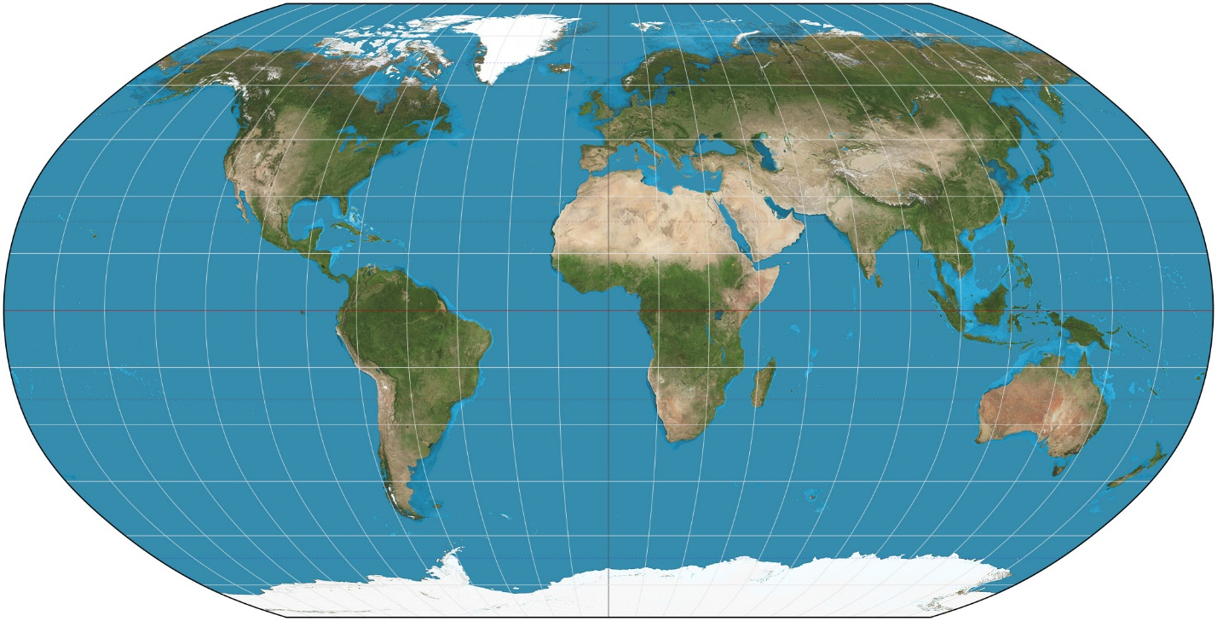

Using the Robinson projection, trace Greenland onto a piece of paper and cut it out.
Questions:
- Compare Greenland to other land areas. List at least two areas that are about the same as Greenland.
- Google the areas you are comparing and record them.
- Based on the actual area of Greenland given by your teacher, are you close? By what factor are you in error? (For example, if you thought you had an area of 100 and the actual area was 20, you are in error by a factor of 5.)
- Does the Robinson projection better represent the true area of polar or equatorial regions? (Hint: look closely at the grid on the map.)
- If the Robinson projection is inaccurate, why is it used?
- What is the only “map” that shows the true sizes and spatial relationships of Earth?

- Answers will vary: US, China, Australia, Europe
- US = 10 million sq km, China = 10 million sq km, Australia = 7.7 million sq km, Europe = 10 million sq km
- 3 – 6
- Equitorial regions
- The Robinson projection is a compromise projection that tries to create a visually appealing map without heavy distortion. The National Geographic Society replaced the Robinson projection with the Winkel tripel projection in 1998.
- A globe! Optional: discuss 3D models

Extension: Use Polar, Van der Grinten, or the Winkel tripel projections with similar questions.

Acknowledgements:
PolarTREC (Teachers and Researchers Exploring and Collaborating)
http://www.polartrec.com/

Arctic Research Consortium of the U.S. (ARCUS)
http://www.arcus.org/arcus/index.html

National Science Foundation
http://www.nsf.gov/

NASA’s Operation IceBridge
http://www.nasa.gov/mission_pages/icebridge/index.html

Libertyville High School
http://lhswildcats.org/

All images are Wikimedia Commons CC-SA-3.0.

