Proctor Professional Outreach Strategy

The Professional Outreach Strategy is a set of ideas for sharing this experience with other professional educators. The Strategy should be unique to your school district and your field experience.

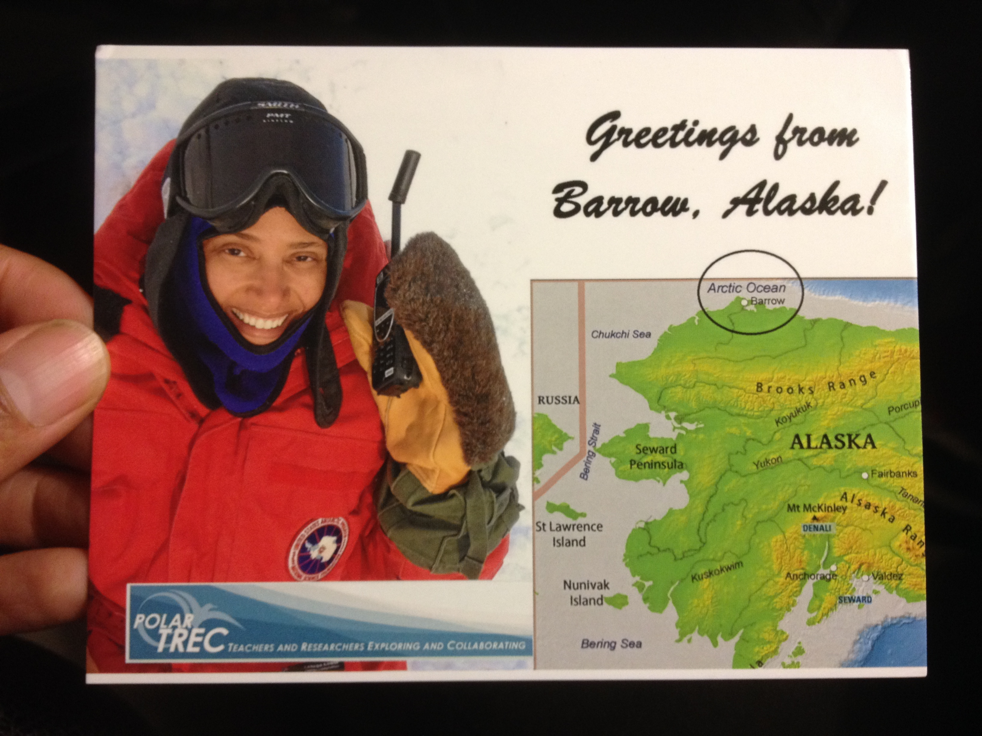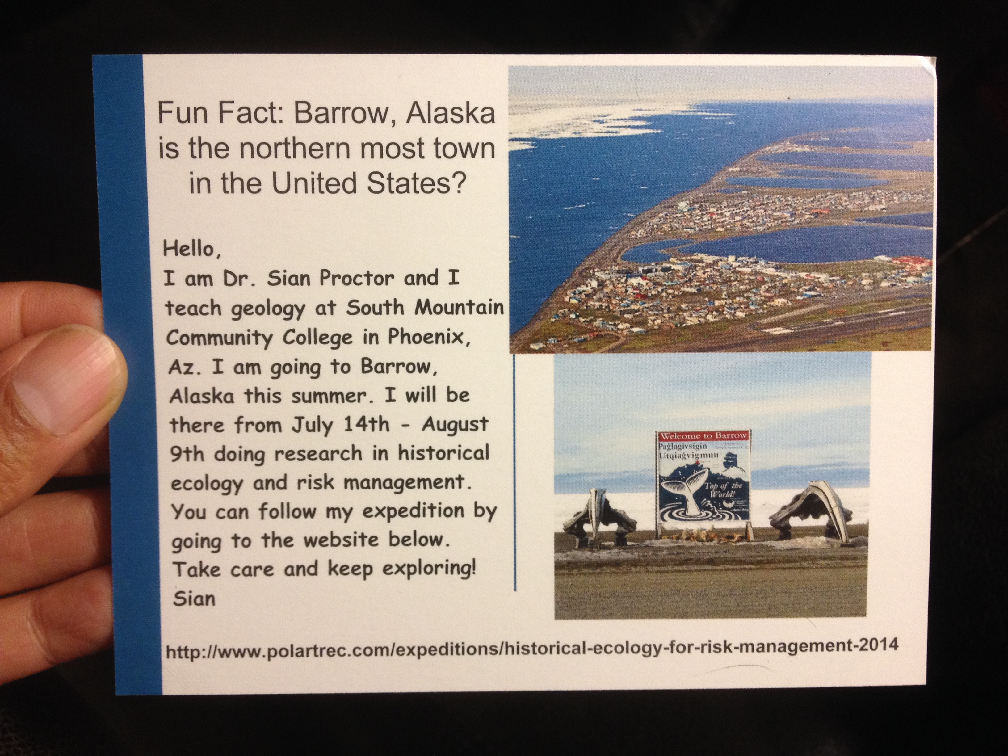
I had 1000 postcards made to promote my upcoming expedition

- What opportunities do you have to share your experience with teachers in your district or state (i.e. conferences, workshops, in-service days, etc.)?
  - I have given a presentation on my campus to my students before the end of the spring 2014 semester and handed out reminder postcards to all my students.
  - I will give a post expedition presentation on my campus that will be open at all students, faculty, staff, and administration.
  - ARIES would be glad to assist virtually in any post expedition presentations as a HERMYS team.
- What can you do to prepare other teachers in your school or district for following your expedition? Do they need access to technology or specific training?
  - I handed out reminder postcards to professors on my campus and I left a stack in my departments main office.
  - I will also send out a school wide email to everyone on my campus (Faculty, Staff, and Administration) when I leave for Alaska. In the email I will remind them how to follow the expedition and encourage them and students to ask questions.
- Are there connections you can make in your school outside the science department?
  - I will send a school wide email when my expedition begins and will emphasis the connection of my research (historical ecology and climate change) to popular classes such as storytelling, cultural communications, and economics.
- Are there regional, state, national, or international conferences that you would be interested in presenting this experience to?
  - I'd like to apply to present at a polar conference. It would be great to collaborate with other PolarTREC teachers to co-present.
  - I would also like to present at the National Association of Geoscience Teachers (NAGT) or a similar organization.
- Where do you plan to share lesson plans or other materials created for your expedition?
  - My lessons are going to shared on my opengeology.com website and as an online module through Softchalk.com. The Softchalk modules will be open to everyone worldwide.
  - I will list my lessons on the Science Education Resource Center (SERC) http://serc.carleton.edu/index.html
  - Lesson plans and research can be posted on the HERMSY website under development as a PolarTREC professional outreach strategy.

