Antarctica 200 Years of Exploration:
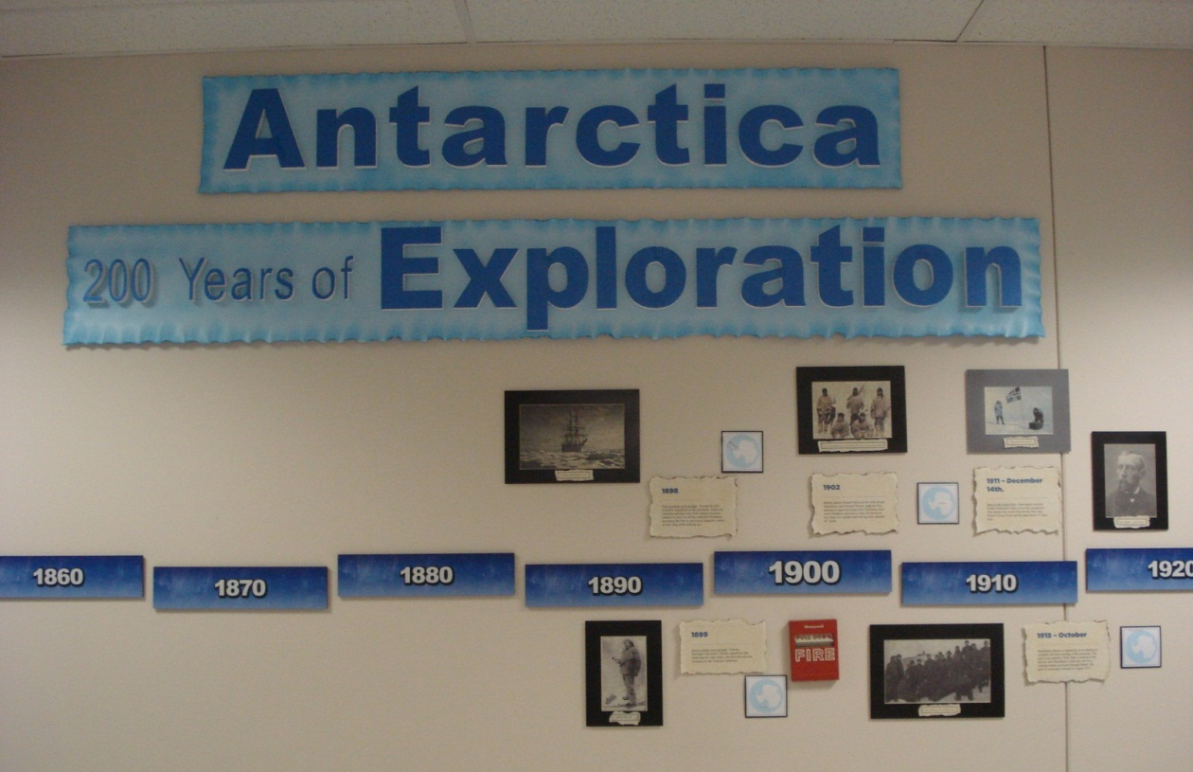

Partial view
Timeline text

- 1773
In January, James Cook crosses the Antarctic Circle and circumnavigates Antarctica. Though Cook does not sight land, he sees deposits of rock in icebergs, suggesting that a southern continent exists.
- 1819 – 21
Russian naval officer Captain Thaddeus Bellingshausen, commanding the ships Vostok and Mirny, crosses the Antarctic Circle (the first since Cook) and sights land. Bellingshausen was the first to truly "discover" a continent since no people were already living there.
- 1821
The first known landing on the continent of Antarctica is made by American sealer Captain John Davis. Davis’s story is not acknowledged by all historians.
- Winter of 1821
First to winter over in the region - An officer and ten men from the British sealing ship Lord Melville became the first to spend a winter in Antarctica. The ship had been driven offshore on King George Island and did not return. The crew was rescued the following summer.
- 1823
In the sea that now bears his name, British whaler James Weddell reaches 74° 15' S, the farthest south of any explorer. No one else is able to penetrate the Weddell Sea again for 80 years.
- 1840’s
Separate British, French, and American expeditions sail along the entire coastline of Antarctica, establishing it as a separate continent.
- 1840
British naval officer and scientist James Clark Ross takes two ships, the Erebus and the Terror, to within 80 miles of the Antarctic coast. The ships are stopped by a massive ice barrier (now known as the Ross Ice Shelf). Clark also discovers an active volcano he names after his ship Erebus and identifies 145 new species of fish.
- 1898
First to winter over on ship - During the first scientific expedition to the continent, Adrien de Gerlache and the crew of the Belgica become trapped in pack ice off the Antarctic Peninsula, becoming the first to survive an Antarctic winter as their ship drifts with the ice.
- 1899
First to winter over on land - Carsten Borchgrevink leads a British expedition that lands men at Cape Adare, the first time anyone wintered on the Antarctic landmass.
- 1902
British captain Robert Falcon Scott, with Ernest Shackleton and Edward Wilson, leads his first attempt to reach the South Pole. Suffering from snow blindness and scurvy, they are forced to turn back two months later having only reached 82° south.
- 1911 – December 14th.
Race to the South Pole - Norwegian explorer Roald Amundsen leads a five man expedition that reaches the South Pole for the first time. Robert Falcon Scott and his team arrive 33 days later.
- 1915 – October
Shackleton returns to Antarctica in an attempt to complete the first crossing of the continent. The goal is not attained. Their ship is crushed in the sea ice, and Shackleton’s team sets out for a whaling station on South Georgia Island. The party is eventually rescued in August 1917.
- 1929
American naval officer Richard E. Byrd and three crew members become the first to fly over the South Pole.
- 1935
Caroline Mikkelsen of Norway is the first woman to set foot on Antarctica when she accompanies her husband Klarius, a whaling captain
- 1947
Operation Highjump, a United States Navy science mission, sends the largest ever expedition to Antarctica, consisting of over 4700 men, 13 ships, and 23 airplanes.
- July 1957 – December 1958
The International Geophysical Year - Twelve nations establish over 60 stations in Antarctica. This marks the beginning of international cooperation in Antarctica and the start of the process by which Antarctica becomes "non-national."
- July 1957
The first successful land crossing via the South Pole is led by British geologist Vivian Fuchs, with New Zealander Edmund Hillary leading a backup party. Their crossing comes 40 years after Shackleton's expedition set out with the same goal.
- 1961
The Antarctic Treaty is established. This international agreement ends new territory claims, thus declaring Antarctica open to scientific expeditions and limited to peaceful uses.
- 1997
Norwegian Boerge Ousland becomes the first person to cross Antarctica unsupported. Towing a 400lb sled, Ousland traveled 64 days from Berkner Island to Scott base.
- March 2007 – March 2009
International Polar Year (IPY) - Over 50,000 people participate in 228 international science projects. The IPY actually spans over two years so that researchers have the opportunity to work in both Polar regions or through summer and winter seasons.
Food Chain:

Intro Panels:
- Antarctica’s Tangled Web
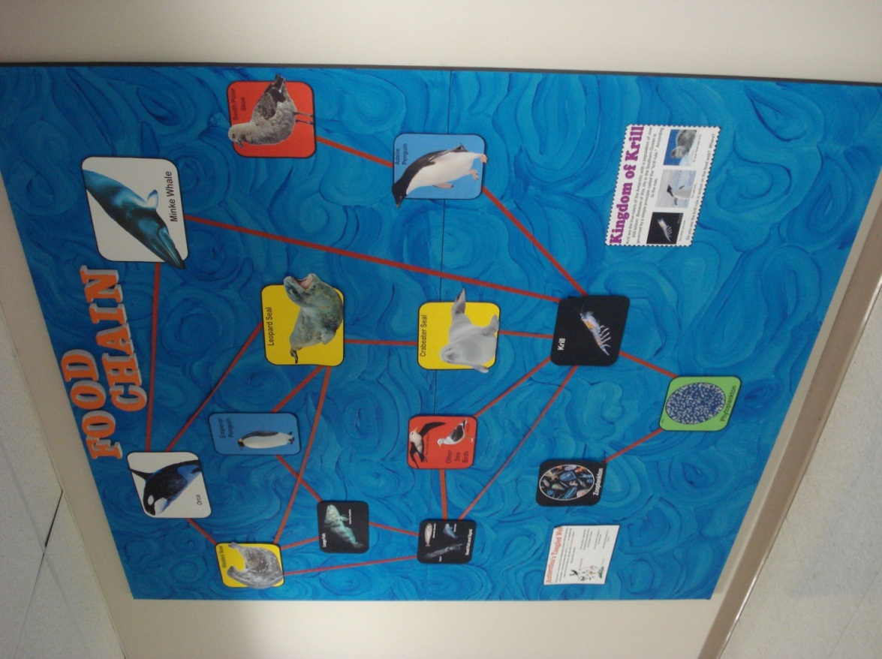
  - A food web is a visual map of the relationships between different animals in an ecosystem. Food webs always start with a producer, an organism that makes its food from the sun, and ends with consumers, animals that eat other animals.
  - This wall gives a glimpse into the amazing ecosystem that is in the Southern Ocean.
  - Can you find the producer in this food web?
  - How many consumers are there?
- Kingdom of Krill
  - Krill are the true rulers of the Antarctic with a population of over 600 billion! Because of this, life in the Southern Ocean is governed by a simple principle called the “krill rule.” According to the rule: You either are krill . . . You eat krill. . . Or your food eats krill.
  - Do you see the krill rule in action on the food web? Where?

Images:
- Phytoplankton
- Krill
- Small Fish and Squid (Squid, Antarctic Silverfish, Borch Fish)
- Large Fish (Antarctic Toothfish)
- South Polar Skua
- Other Sea Birds (Black Browed Albatross, Kelp Gull)
- Emperor Penguin
- Adélie Penguin
- Weddell Seal
- Crabeater Seal
- Leopard Seal
- Orca
- Minke Whale
- Zooplankton
Greetings From:
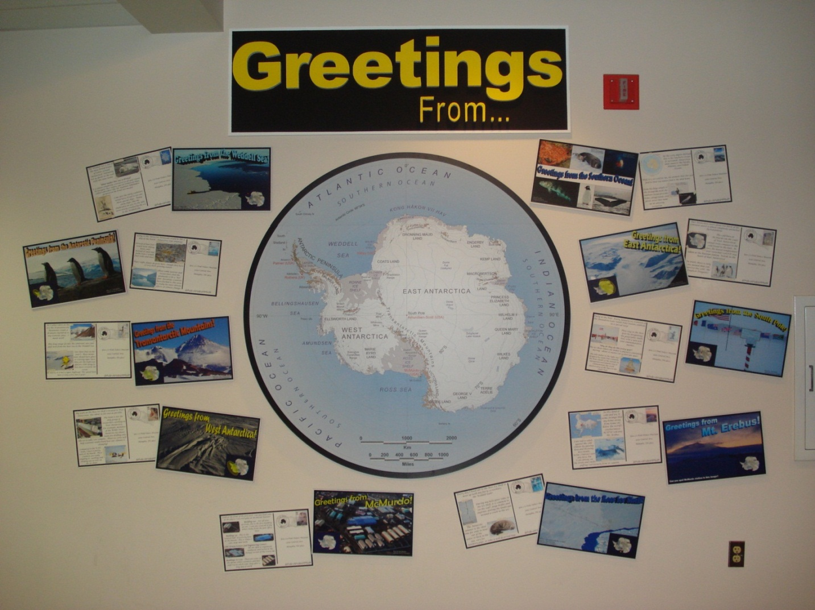
Antarctic Peninsula
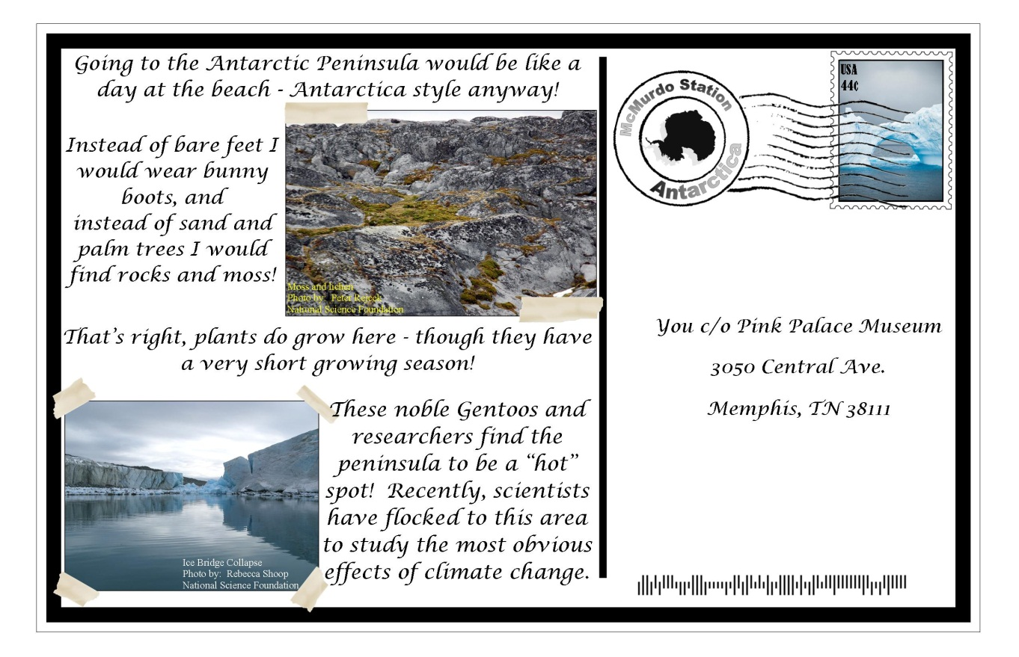

East Antarctica
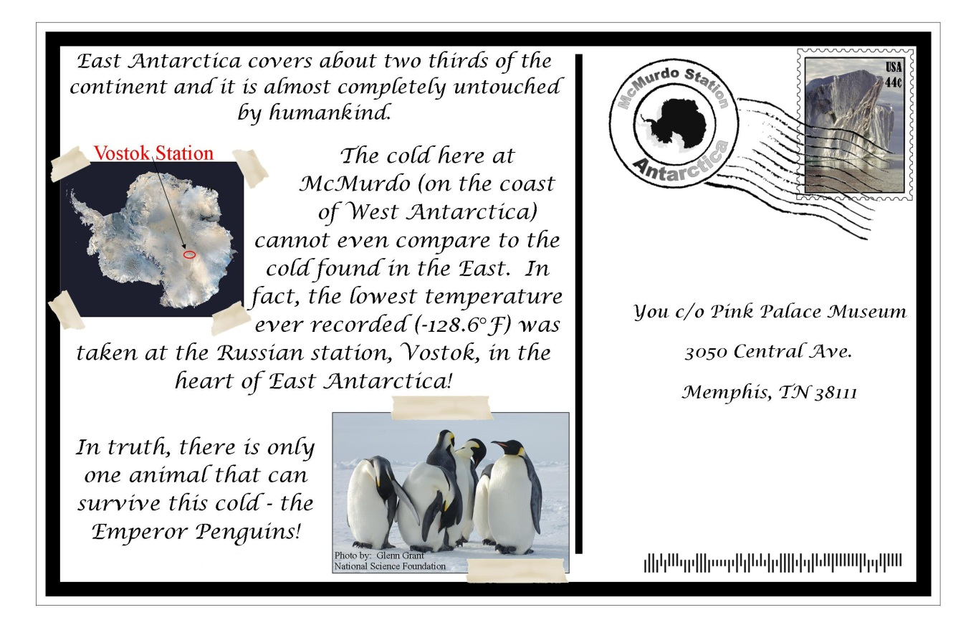

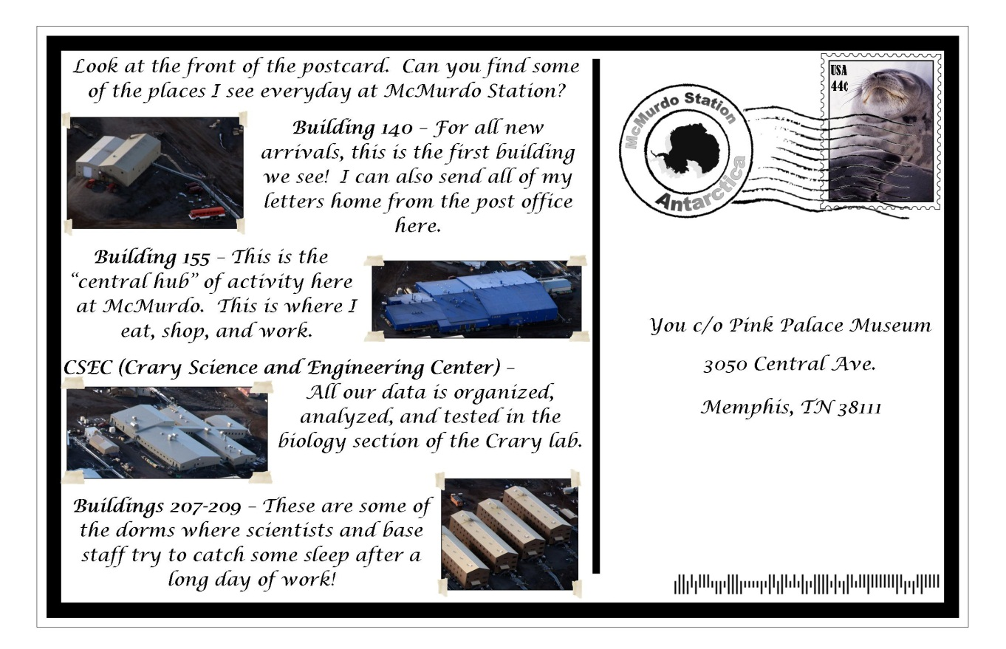
McMurdo Station
Mt. Erebus
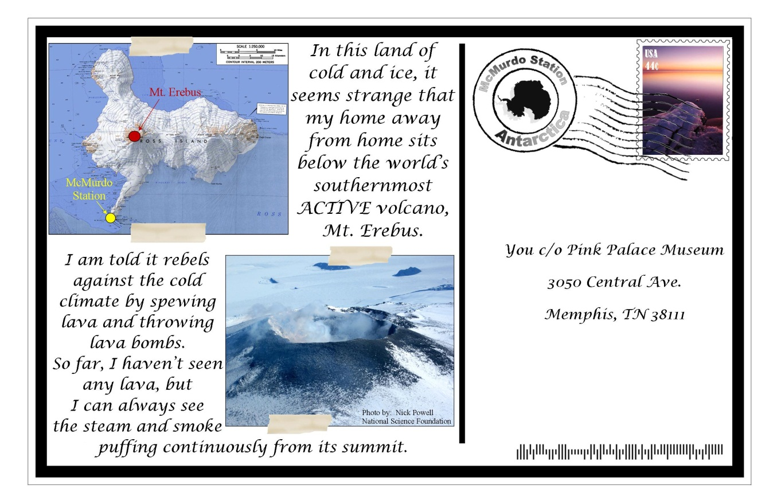

Ross Ice Shelf
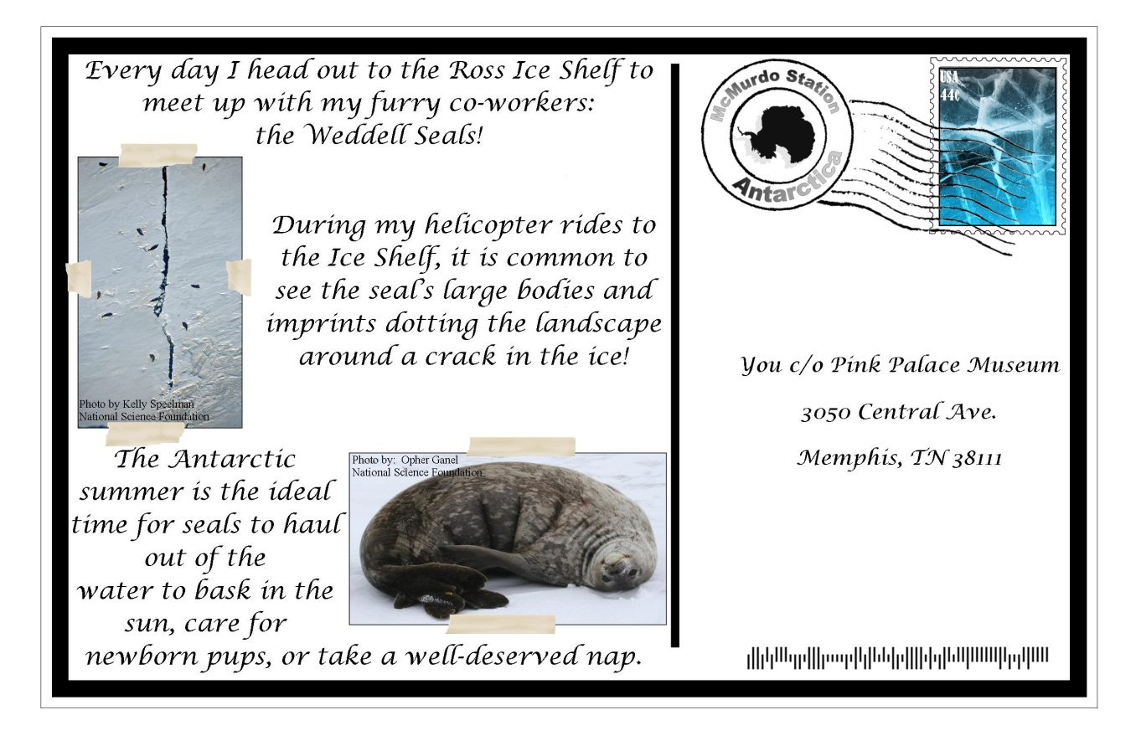

South Pole

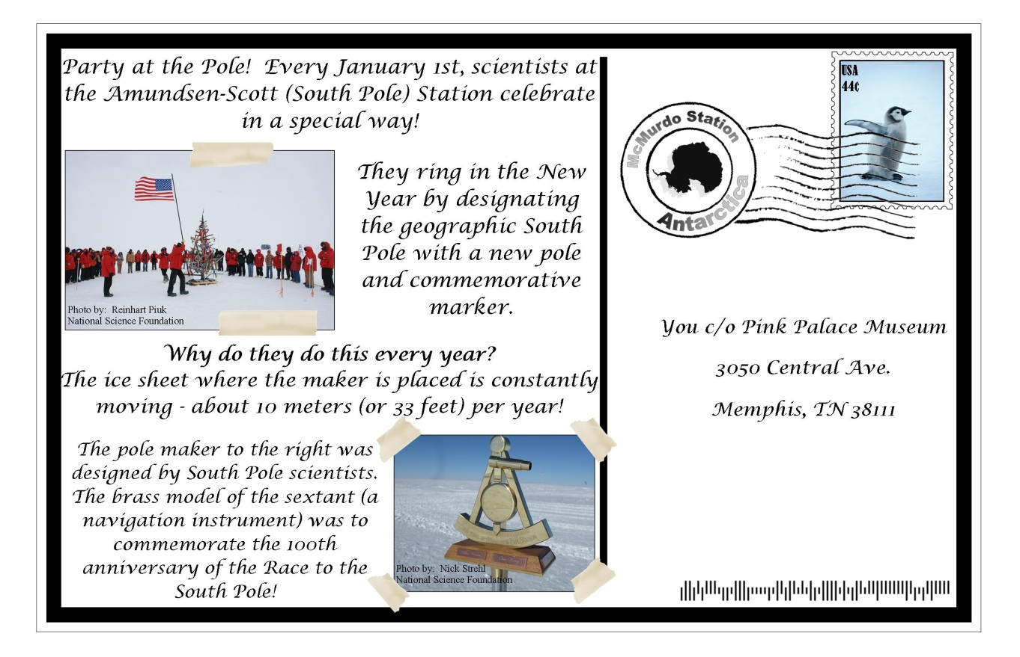

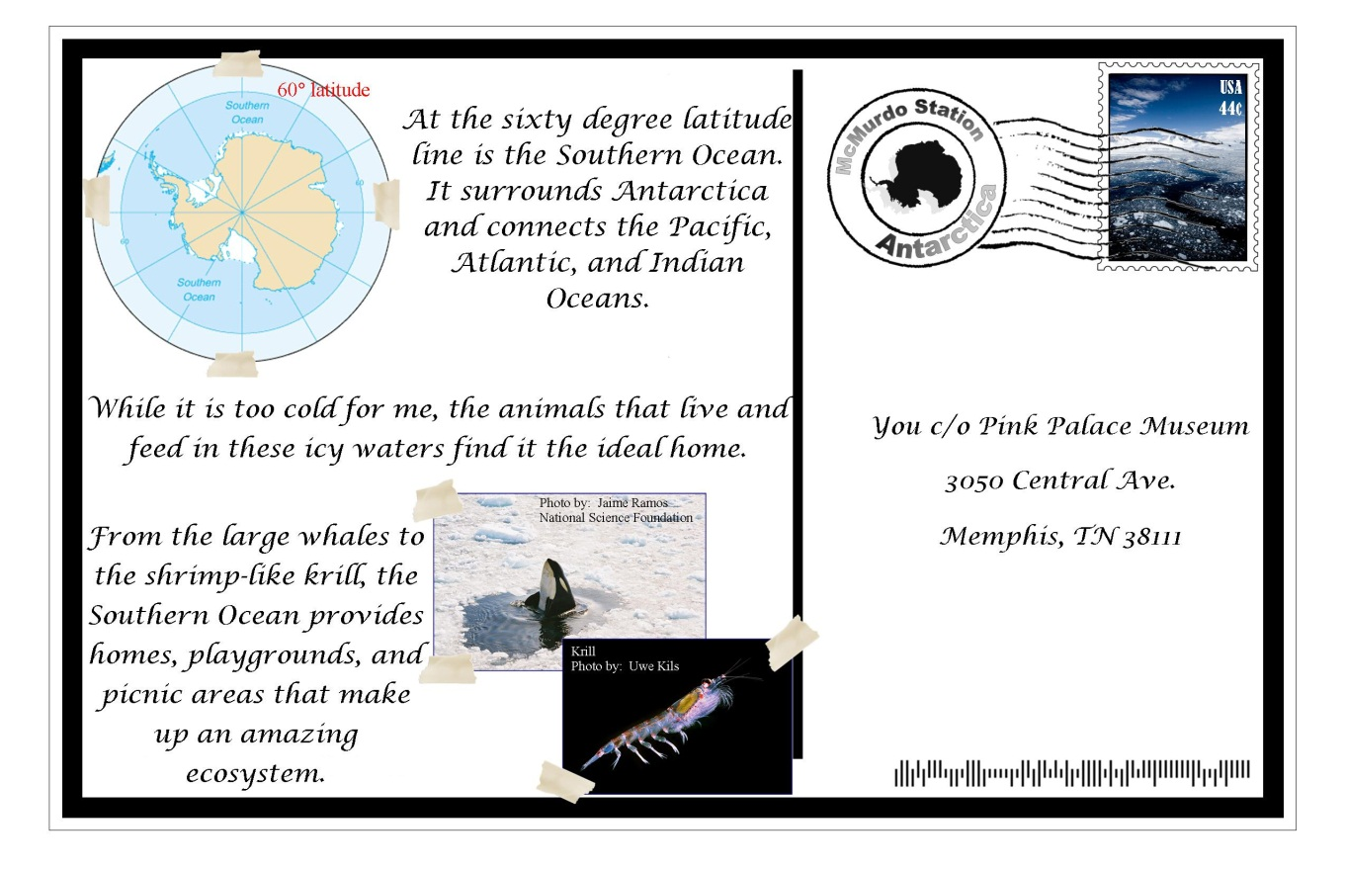
Southern Ocean
Transantarctic Mountains
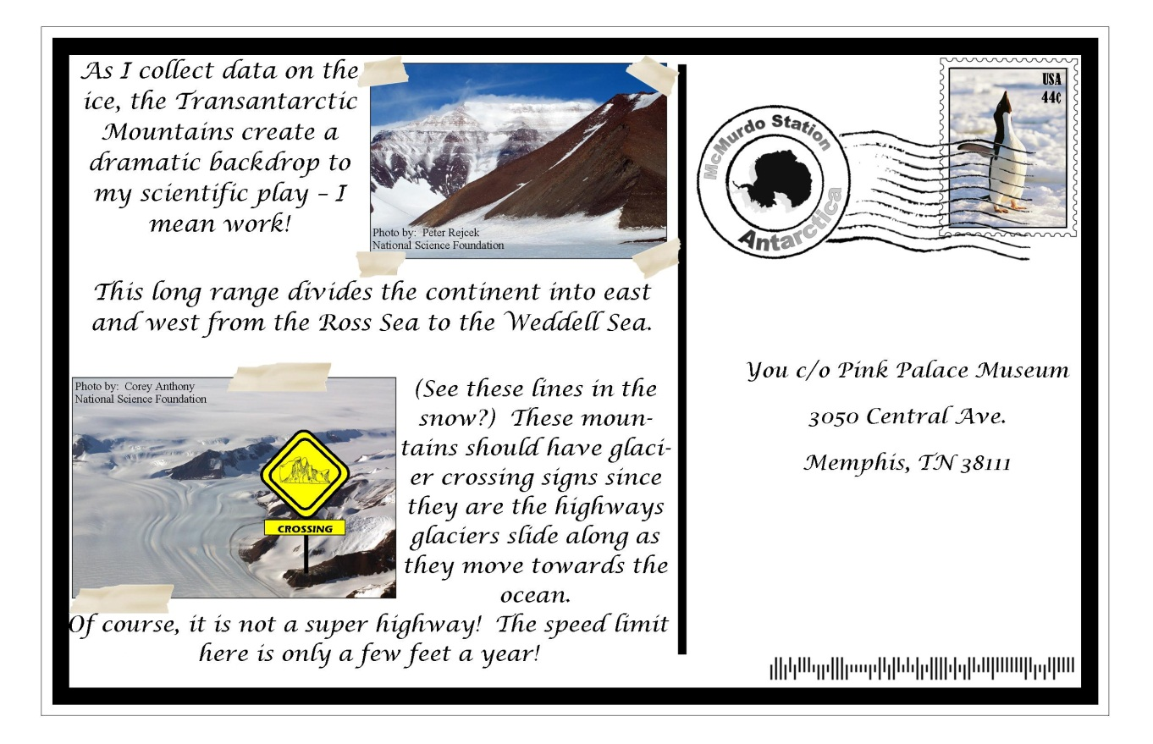
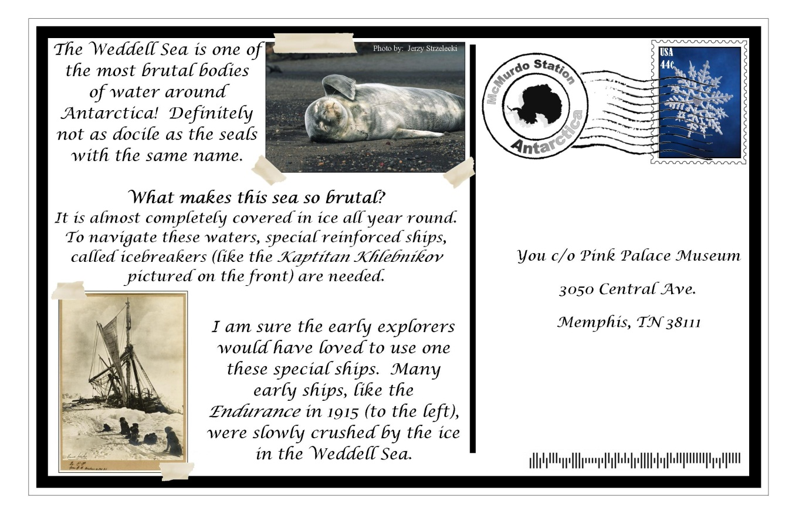
Weddell Sea

West Antarctica
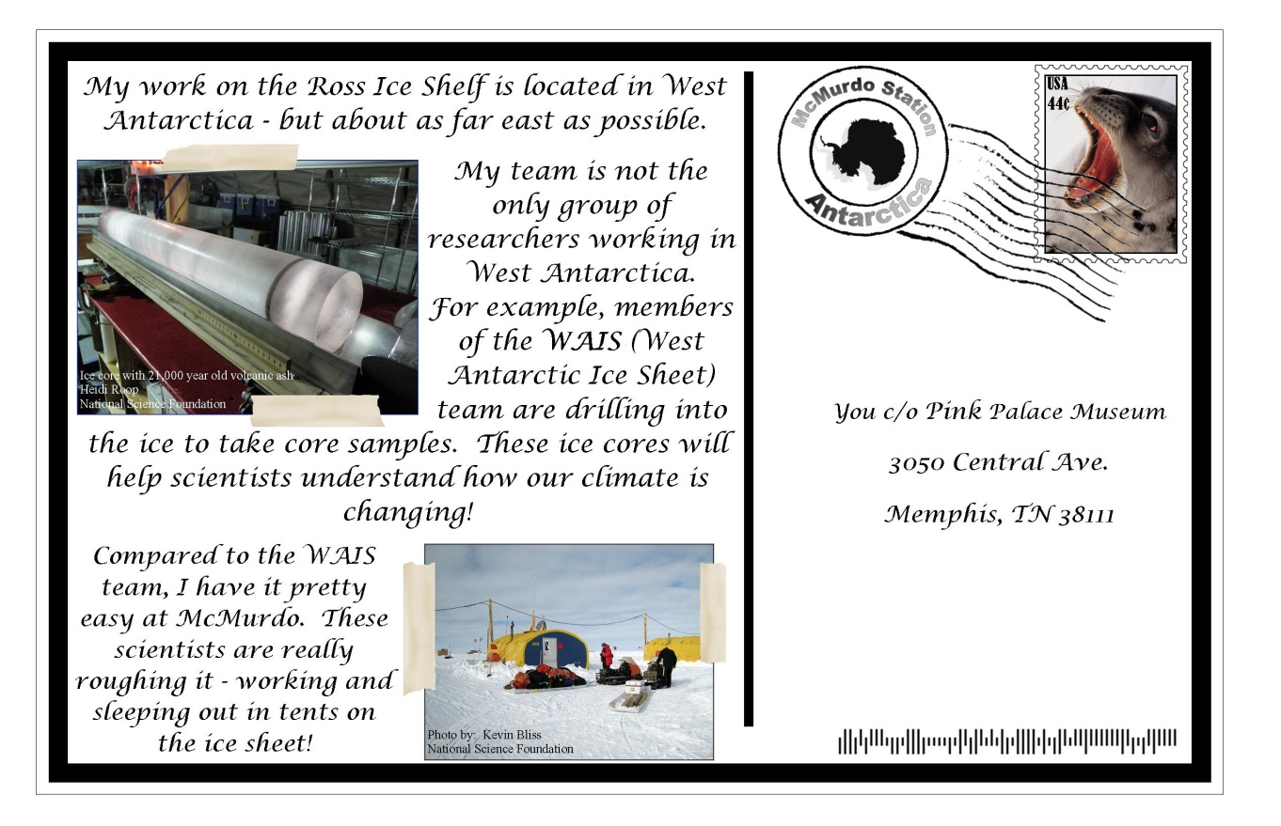

Extreme Antarctica:
