Stay Alive at -55°

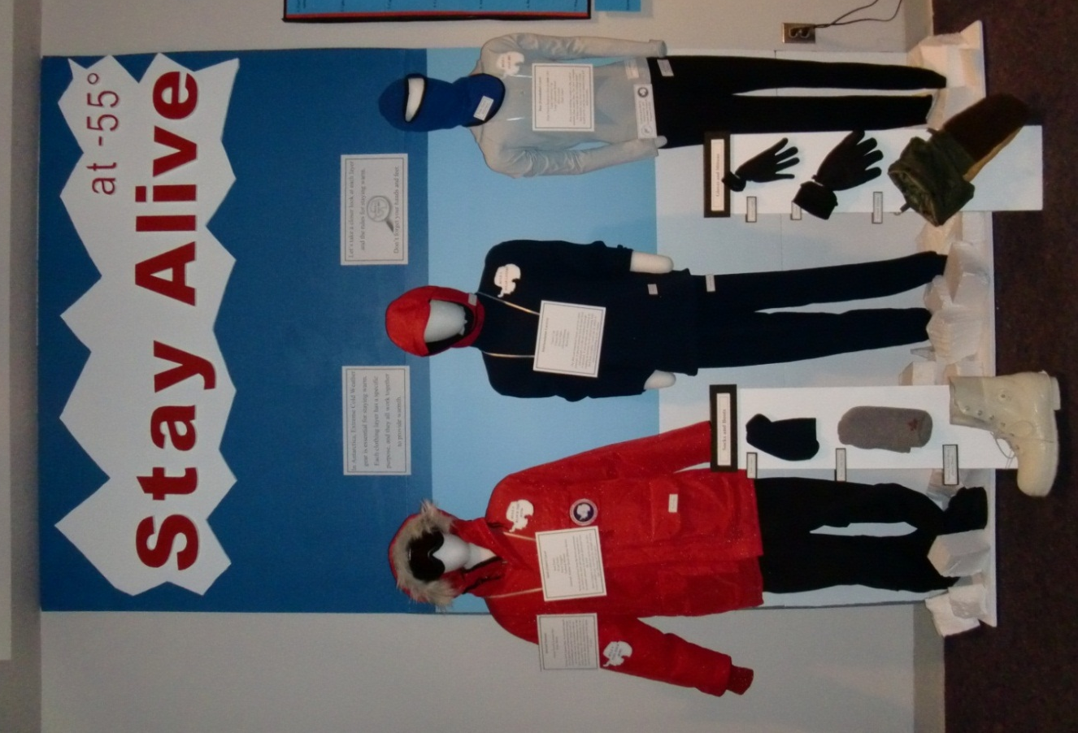

Wall Panels:
- In Antarctica, Extreme Cold Weather gear is essential for staying warm. Each clothing layer has a specific purpose, and they all work together to provide warmth.
- Let’s take a closer look at each layer and the rules for staying warm.
Don’t forget the hands and feet.

Rule Signs:
- Rule 1: Stay Dry
- Rule 2: Wear Layers
- Rule 3: Block the Wind
- Rule 4: Fuel Your Body

Signs on Mannequins:

Base (Foundation) Layer
- Polar Fleece Balaclava [bal-uh-klah-vuh]
- Long Underwear Top
- Long Underwear Bottom
- Glove Liners
- Sock Liners
Base Layer clothing is made of silk, wool or synthetic (man-made) fibers. This layer is designed to keep your body dry by wicking sweat and moisture away from your body. Cotton should not be worn because it absorbs sweat and holds moisture.

Mid/Insulation Layer(s)
- Yazoo Cap
- Fleece Shirt
- Fleece Pants
- Gloves/Mittens
- Wool Socks
The Mid and Insulation Layers serve two main purposes. It absorbs moisture from the base layer and transports it to the environment through evaporation. It also provides extra insulation by trapping air between layers and preventing body heat from escaping. Layers can be added or removed depending on the weather.

Shell (Outer) Layer
- Red Parka
- Wind Pants
- Snow Goggles
- Furback Mittens
- Thermal, Rubber Boots (Bunny Boots)
Worn for protection from the harsh environment, the Shell is the outer and most important layer.
Its primary purpose is to provide protection from the wind.
Snow Goggles, or other eye protection, are also worn to shield your eyes from the sunlight and the light reflecting off the snow.

Internal Furnace
- Energy Food/Chocolate Bars
- Water Bottle
Staying warm requires food. As your body digests food, it generates much needed heat and energy. Carbohydrates are excellent “energy foods” and can be tucked away in the pockets of the red parka. Just make sure the carbohydrates you take can be eaten frozen - like a chocolate bar. In the dry and windy Antarctic climate dehydration is a concern. It is therefore important to drink plenty of water.
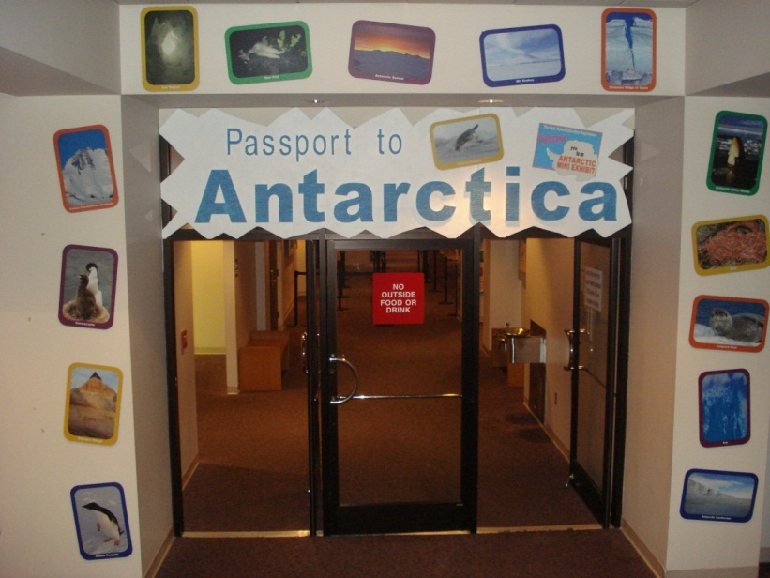
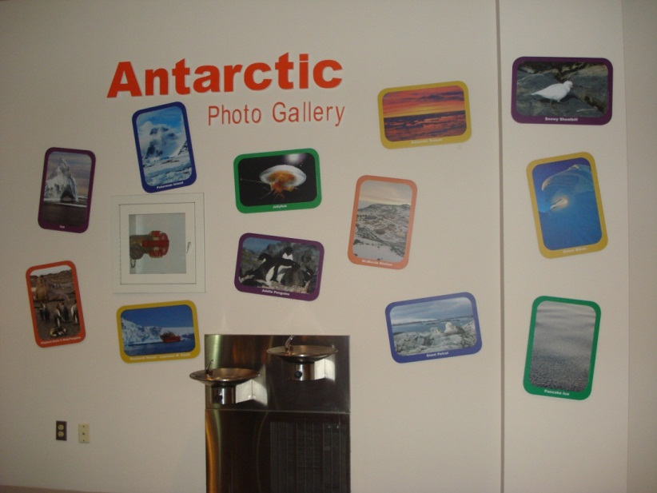
Antarctic Photo Gallery
Images Featured:

- Antarctic Explorer – Robert Falcon Scott
- Lake Fryxell
- Star Fish
- Aurora Australis (3)
- Antarctic Killer Whales (3)
- Skua
- Glaciers
- Antarctic Sunset (4)
- Emperor Penguin (3)
- Crabeater Seals (2)
- Research Vessel – Laurence M. Gould
- Krill
- Sea Spider
- Leopard Seal (2)
- Iceberg
- Pressure Ridges of Snow (2)
- Adélie Penguins (3)
- Snowy Sheatbill
- Bull Pass, Victoria Land
- Lichen
- Giant Petrel
- Antarctic Landscape
- Mt. Erebus
- Minke Whale and Emperor Penguin
- Antarctic Explorer Ernest Shackleton
- Antarctic Explorer Roald Amundsen
- Petermen Island
- Rocky Outcropping
- Pancake Ice
- Snow Wave
- Olympus Range
- Ice Tunnel
- Elephant Seals & King Penguins
- McMurdo Station
- Central Transantarctic Mountains
- Ice (2)
- Cormorants
- Jellyfish
- Sunset over Pancake Ice

Weddell Seal Family:
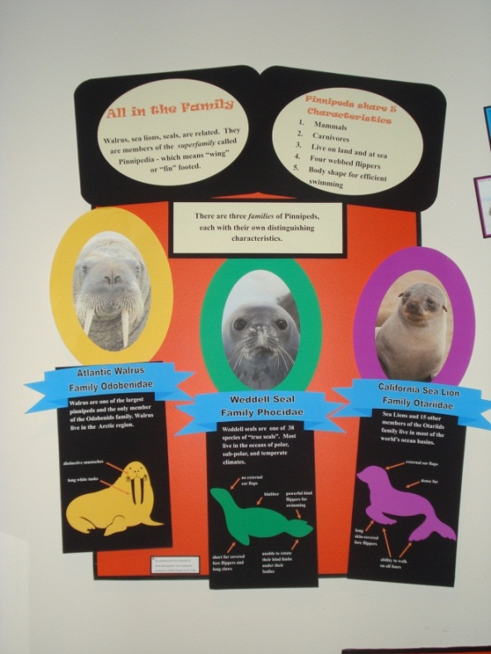
All in the Family - Walrus, sea lions, seals, are related. They are members of the superfamily called Pinnipedia - which means “wing” or “fin” footed.

Pinnipeds share 5 Characteristics
1. Mammals
2. Carnivores
3. Live on land and at sea
4. Four webbed flippers
5. Body shape for efficient swimming

There are three families of Pinnipeds, each with their own distinguishing characteristics.

Atlantic Walrus
Family Odobendidae
Walrus are one of the largest pinnepeds and the only member of the Odobenids family. Walrus live in the Arctic region.
- distinctive mustaches
- long white tusks

Weddell Seal
Family Phocidae
Weddell seals are one of 38 species of “true seals”. Most live in the oceans of polar, sub-polar, and temperate climates.
- no external ear flaps
- blubber
- powerful hind flippers for swimming
- short fur covered fore flippers and long claws
- unable to rotate their hind limbs under their bodies

California Sea Lion
Family Otariidae
Sea Lions and 15 other members of the Otariids family live in most of the world’s ocean basins.
- external ear flaps
- dense fur
- long skin-covered fore flippers
- ability to walk on all fours
- The Weddell Seal
The Weddell Seal – Stats
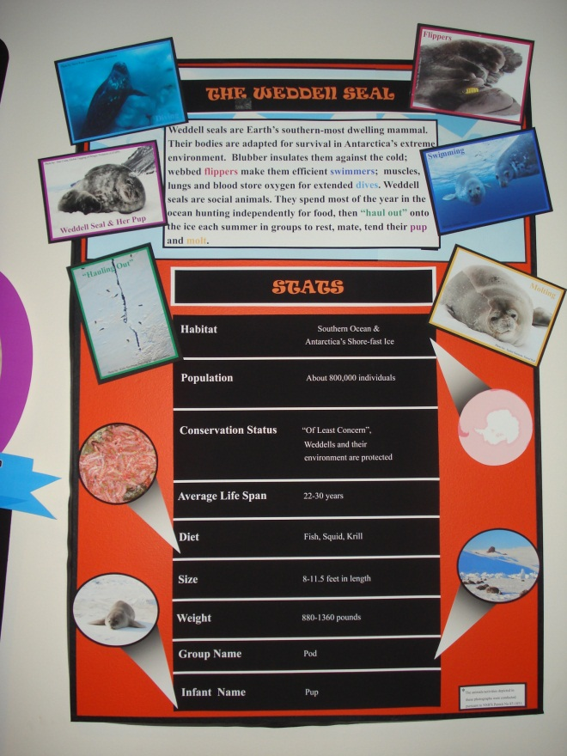

Weddell seals are Earth’s southern-most dwelling mammal. Their bodies are adapted for survival in Antarctica’s extreme environment. Blubber insulates them against the cold; webbed flippers make them efficient swimmers; muscles, lungs and blood store oxygen for extended dives. Weddells are social animals. They spend most of the year in the ocean hunting independently for food, then “haul out” onto the ice each summer in groups to rest, mate, tend their pup and molt.
Stats:
- Habitat- Southern Ocean & Antarctica’s Shore-fast Ice
- Population- About 800,000 individuals
- Conservation Status- “Of Least Concern”, Weddells and their environment are protected
- Average Life Span- 22-30 years
- Diet- Fish, Squid, Krill
- Size- 8-11.5 feet in length
- Weight- 880-1360 pounds
- Group Name- Pod
- Infant Name- Pup

Scientific Classification of the Weddell Seal

Where do I fit in?
All living things are classified according their shared characteristics and common ancestry.

Kingdom: Animalia
- All living things belong to one of five kingdoms. Weddell seals belong to the animal kingdom.
Phylum: Chordate
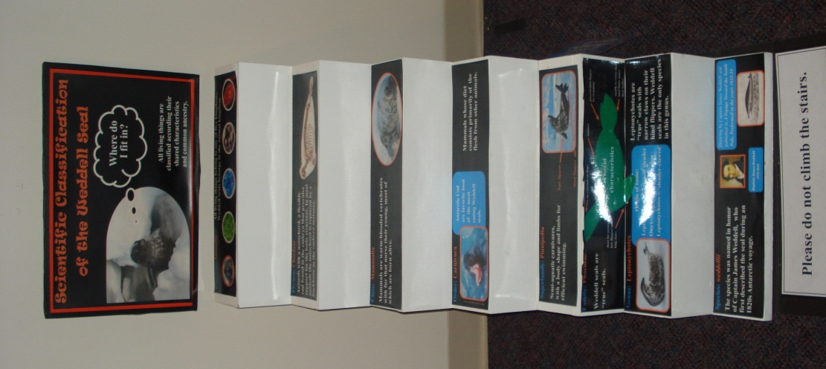
- Animals with a notochord, a flexible rod found in the embryo that provides support for the body structure. In most animals the notochord is replaced by a backbone as the embryo matures.
Class: Mammalia
- Mammals are warm-blooded vertebrates with fur that nurse their young, most of which are born alive.
Order: Carnivora
- Mammals whose diet consists primarily of the flesh from other animals.
- Antarctic Cod are favorite food of the meat eating Weddell seals.
Superfamily: Pinnipedia
- Semi-aquatic carnivores, with a body shape and limbs for efficient swimming.
Family: Phocidae
- Weddell seals are “true” seals.
Genus: Leptonychotes
- Leptonychotes are “true” seals with narrow claws on their hind flippers. Weddell seals are the only species in this genus.
- Origin of Name:
  - Leptos- Greek for fine or slender
  - Onyx- Greek for nail or claw
  - Leptonychotes = “slender-clawed”
Species: weddellii
- The species was named in honor of Captain James Weddell, who first described the seal during an 1820s Antarctic voyage.

Take a Closer Look at the Weddell Seal:
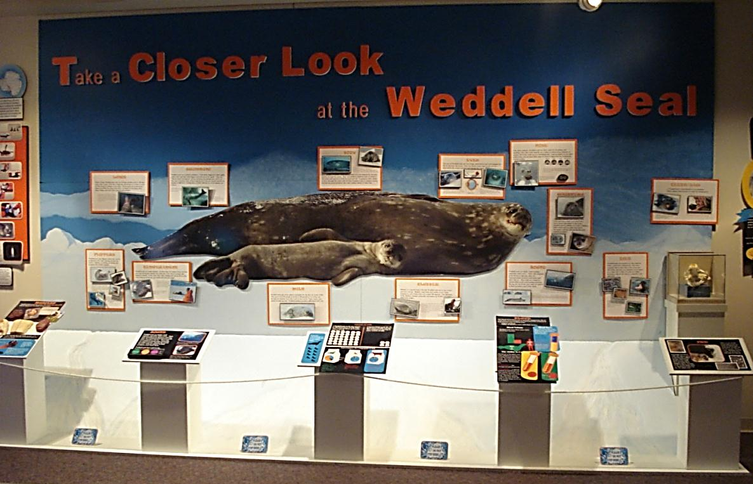

Blood
- The blood of Weddell seals is specially adapted for life in
Antarctica. Let’s compare two characteristics of blood in both humans and Weddell seals:
  - Volume of blood
  - Ability of blood to carry and store oxygen
- Blood Volume
  - Weddell seals have three times more blood than humans
  - 20-22% Blood or 60 Liters
  - 7-8% Blood or 4-6 Liters
- Blood Parts
  - Let’s take a closer look at this complex topic. The blood of all mammals is made up of four parts, each with a specific function.
  - Plasma – carries blood cells, nutrients, proteins, hormones and waste throughout the body
  - White Cells - fights infection
  - Platelets - helps blood clot and wounds heal
  - Red Cells – transports oxygen from the lungs to tissues in the body, and then carry away waste like carbon dioxide
- The Ability to Carry and Store Oxygen
  - The blood of Weddell seals is better adapted at storing and carrying oxygen than human blood. Two measures of red blood cells, hematocrit and hemoglobin, demonstrate this.
  - Hematocrit — the amount of red blood cells.
  - Hemoglobin — a special protein in red blood cells that carries oxygen from the lungs to the rest of the body, and then returns carbon dioxide from the body to the lungs so it can be exhaled.
Blubber
- Blubber is a special kind of fat that Weddell seals use to stay warm and store energy. Blubber traps body heat inside a seal’s body, keeping its core temperature at around 100 degrees. The thickness of the blubber changes seasonally and makes up 30-40% of a seal’s total body weight.
- During winter when seals feed in the ocean, they build up a blubber layer of over two inches. In the summer, mother seals consume much of their blubber layer feeding their pups. By January, they are at their thinnest and ready to return to the sea to rebuild their fat and energy supply.
- Researchers measure seal blubber with ultrasound technology.

Body
- Weddell seals measure 8-10 feet in length and weigh 880-1320 pounds. Their girth, the measurement at the widest part, averages almost 7 feet around. Females are slightly larger than males.
- Even though a Weddell’s body is enormous, it is well-adapted for moving quickly through the water. Their streamlined, fusiform body is round at the center and tapered at both the head and tail. It optimizes their ability to move through the water with the least resistance and is common among fast-moving ocean predators like seals, whales, sharks and other fish.

Diet
- Weddell seals are carnivores; they feed on fishes, squid and crustaceans. The most common fish in their diet is the Antarctic Silverfish and they can consume ten or more in a single dive. Other favorites are Bald notothen (‘Borch’ for short), Antarctic Cod and krill.
- Atlantic Cod weigh up to 70 pounds and must be brought to the surface to be eaten.
- Scientists have observed seals “capturing their prey” by blowing bubbles into ice holes to scare out “borchs” so they can quickly gobble them up.

Eyes
- The eyes of Weddell seals are very large, dark brown and well adapted for life in and near the ocean. They see clearly where light levels are low—deep below the ocean’s surface and during the winter.
- Seals eyes have round lenses which enable them to see well through water. Land animals have flattened lenses to see well through air.
- The corneas of a seal’s eye are with protective mucus that looks like and washes bacteria from sea water.
Flippers
- Weddells have four flippers which they use for swimming in the water, moving on land, for balance, fighting, scratching, grooming and propping their bodies upright.
- Their flippers are wide, flat, fin-like structures with webbing between all five digits of each flipper. They are covered in velvety fur with claws near the end of each digit.
- Because much of the seal’s “arm” and “leg” bones are located within their bodies, they appear shorter than appendages of land animals.

Fur
- Seal pups are born with soft, fuzzy gray or brown fur, called lanugo, that keeps them warm while they develop their blubber layer. At four to six weeks pups molt or shed their baby fur for an adult coat.
- After a year in the ocean and on the ice, adult Weddell seals shed their scruffy old fur for a new silvery coat. Molting usually begins in December and ends in March.

Lungs
- Before diving, Weddell seals take several huge breaths of air to fill their lungs with oxygen. Then they exhale the remaining air to make it easier for their lungs to collapse as they dive. The pressure all around their bodies intensifies the deeper they dive. At about 229 feet deep, their lungs collapse and their chest capacity gets smaller.
- As the seal swims and expends energy, its lungs provide a steady supply of oxygen to its brain, heart and muscles. The longest recorded Weddell dive is 89 minutes, but seals typically dive for 15-20 minutes before coming up for air.

Milk
- Pups nurse almost constantly for the first six weeks of life and require nine quarts of milk per day. They grow from 60 pounds at birth to 250 pounds by six weeks and develop the blubber layer that will keep them warm. Weddell mothers produce milk that is 60% fat.
- Let’s Compare the Components of Milk
  - Human infants consume about 40 grams of fat each day.
  - Ever wonder why people drink cow’s milk. Take a look at how it compares to human milk.
- Amount of Milk
  - A Weddell pup needs nine quarts or 288 fluid ounces of milk daily. That would fill thirty-six 8 ounce cartons of milk.
  - A human infant needs 20 - 32 fluid ounces of milk each day. That compares to just four 8 ounce cartons of milk.
- In one day, a Weddell pup can drink as much milk as nine human babies.

Muscles
- Muscles need oxygen for energy. The darker the color of the muscle, the greater its ability to store oxygen.
- Look at the flesh of these animals. Which has the greatest ability to store oxygen?
- Cow’s muscles have an ability to store a lot of oxygen, but the muscles of Weddell seals can store even more.
- The magnified muscle to the left is highly efficient and almost black in color.
- Weddell muscle is particularly good at storing oxygen because it has a lot of myoglobin. This large amount of myoglobin makes it possible for Weddell seals to dive underwater for long periods of time.

Nose
- Like other animals, Weddell seals use their noses for breathing and smelling. They flare their nostrils very widely to inhale large amounts of oxygen when they come up to a breathing hole. Seals probably do not smell underwater, but on land, their sense of smell is important for recognizing a mate or pup.
- They close their noses super tight when they go on a dive, and as they get deeper, their noses close even tighter to keep the water out.
- Weddells flare their nostrils to the size of a quarter when they come up for air.

Teeth/Jaw
- A Weddell seal’s teeth identify it as a predator. Their canines and incisors are used for seizing prey.
- Their front teeth stick out slightly to aid in reaming (or breaking) ice to maintain breathing holes.
- Weddells can open their jaws really wide. This helps them ream the ice and swallow fish whole.

Temperament
- Weddell seals are social animals. On dives they are almost always on their own, but during the summer they haul out of the ocean in groups and breed in colonies. In the water they hunt continuously but on the ice they rest, warm up in the sun, give birth and tend their pups.
- Weddells usually have a calm temperament around people. They have no natural land enemies and little reason to be defensive around humans.
- At times males will compete for territory and for access to breathing holes.

Sound
- Weddell seals are highly vocal animals, especially underwater. Their calls transmit great distances and may allow for communication between seals below and above the ice.
- Most calls are related to summertime social and breeding activities. During the rest of the year, seals are quieter so their predators won’t hear them.
- Moms and pups communicate with calls to recognize, locate and maintain contact with each other.
- Males are usually louder and more vocal than females and use calls to attract a female, compete with another male and defend breathing holes.
- Weddell seals have a lot to say. Scientists have identified 34 different call types. Press to listen. What do you think is being communicated?

Whiskers
- Seals have whiskers surrounding their noses and above their eyes which they use to detect movement in the water. Sensitive nerve endings on a seal’s whiskers help it hunt and navigate deep below the ocean’s surface and during the dark months of winter.
- A seal may flare her whiskers when she senses something of interest in her environment.

Weddell Research
Since the 1960s, scientists have travelled from all over the world to study Weddell seals at McMurdo Station. These studies are among the longest continuous scientific investigations of any long-lived mammal in its natural habitat. To date, over 17,000 Weddell seals have been tagged for tracking. The data collected is increasing our knowledge about Weddell seals and climate change.

- Find & Select Seals Suitable for Study
The research team travels by helicopter or snowmobile to find seals that are hauled out on the ice. The team selects seals that are in good general health and have completely molted (shed) their fur.
- Upload & Cart our Gear
Equipment is taken from the helicopter or snowmobile loaded onto sleds and pulled across the ice near the location of the study seal.
- Capture a Seal
When scientists capture a seal they approach and sedate the seal—following strict rules. Weddell seals have a calm temperament and are generally easy to approach.
- Collect Data
Researchers examine the seals to assess their overall health. Seals are measured, weighed and samples of blood are taken. Fur, claw and whisker clippings are used to determine the seal diet. Researchers also measure the thickness of seals’ blubber using ultrasound.
- Attach a Satellite Tag
In the Antarctic summer, scientific equipment like this satellite tag is attached to the head of Weddell seals in order to learn more about their behavior in the water. The tag is applied with epoxy (glue) and should remain on the seals until collected by researchers.
- Release the Seal
When the seals are released - data collection begins.
During the Antarctic winter, the satellite tag will record and monitor the behaviors of each seal.
Tags are collected several months later.
- What Scientists are Finding
Scientists are already learning a lot about Weddell seal diving behavior. This diagram shows the pattern of a Weddell seal’s dive. This seal dove in a straight path to a depth of 403 meters (1322 feet) —greater than the height of the Empire State Building. Then the seal returned to the surface on a meandering path feeding on fish, squid and krill. Follow the dive path. When was the seal most likely feeding?
- Encourage the Next Generation of Polar Scientists
The National Science Foundation (NSF), science researchers and PolarTREC seeks to open pathways to polar science education by bringing K-12 educators and polar researchers together. This project hopes to increase students’ knowledge and interest in polar science, technology, engineering or mathematics (STEM) careers.
Would you like to become a polar scientist?
Antarctica 200 Years of Exploration:
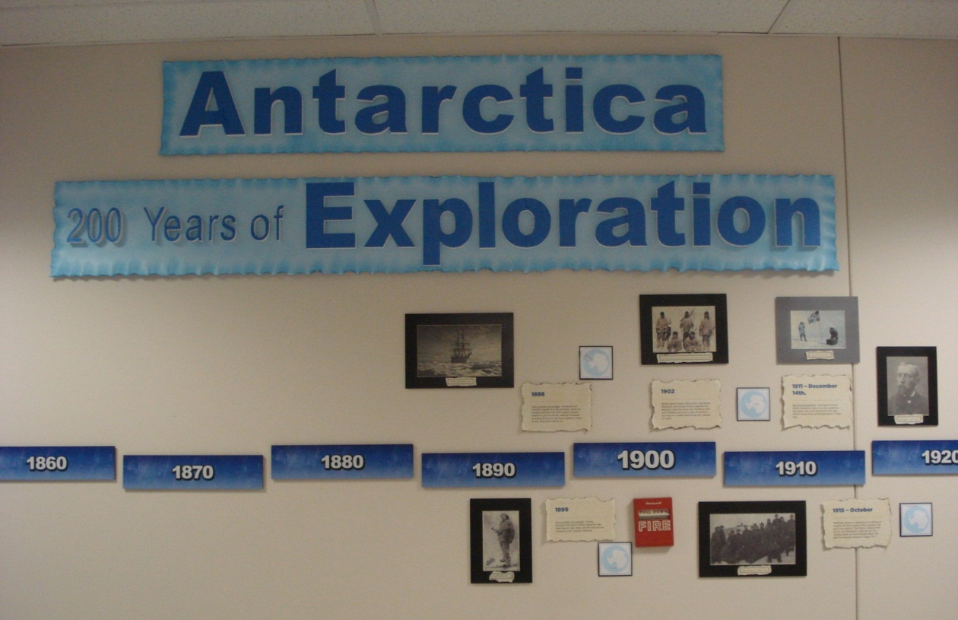

Partial view
Timeline text

- 1773
In January, James Cook crosses the Antarctic Circle and circumnavigates Antarctica. Though Cook does not sight land, he sees deposits of rock in icebergs, suggesting that a southern continent exists.
- 1819 – 21
Russian naval officer Captain Thaddeus Bellingshausen, commanding the ships Vostok and Mirny, crosses the Antarctic Circle (the first since Cook) and sights land. Bellingshausen was the first to truly "discover" a continent since no people were already living there.
- 1821
The first known landing on the continent of Antarctica is made by American sealer Captain John Davis. Davis’s story is not acknowledged by all historians.
- Winter of 1821
First to winter over in the region - An officer and ten men from the British sealing ship Lord Melville became the first to spend a winter in Antarctica. The ship had been driven offshore on King George Island and did not return. The crew was rescued the following summer.
- 1823
In the sea that now bears his name, British whaler James Weddell reaches 74° 15' S, the farthest south of any explorer. No one else is able to penetrate the Weddell Sea again for 80 years.
- 1840’s
Separate British, French, and American expeditions sail along the entire coastline of Antarctica, establishing it as a separate continent.
- 1840
British naval officer and scientist James Clark Ross takes two ships, the Erebus and the Terror, to within 80 miles of the Antarctic coast. The ships are stopped by a massive ice barrier (now known as the Ross Ice Shelf). Clark also discovers an active volcano he names after his ship Erebus and identifies 145 new species of fish.
- 1898
First to winter over on ship - During the first scientific expedition to the continent, Adrien de Gerlache and the crew of the Belgica become trapped in pack ice off the Antarctic Peninsula, becoming the first to survive an Antarctic winter as their ship drifts with the ice.
- 1899
First to winter over on land - Carsten Borchgrevink leads a British expedition that lands men at Cape Adare, the first time anyone wintered on the Antarctic landmass.
- 1902
British captain Robert Falcon Scott, with Ernest Shackleton and Edward Wilson, leads his first attempt to reach the South Pole. Suffering from snow blindness and scurvy, they are forced to turn back two months later having only reached 82° south.
- 1911 – December 14th.
Race to the South Pole - Norwegian explorer Roald Amundsen leads a five man expedition that reaches the South Pole for the first time. Robert Falcon Scott and his team arrive 33 days later.
- 1915 – October
Shackleton returns to Antarctica in an attempt to complete the first crossing of the continent. The goal is not attained. Their ship is crushed in the sea ice, and Shackleton’s team sets out for a whaling station on South Georgia Island. The party is eventually rescued in August 1917.
- 1929
American naval officer Richard E. Byrd and three crew members become the first to fly over the South Pole.
- 1935
Caroline Mikkelsen of Norway is the first woman to set foot on Antarctica when she accompanies her husband Klarius, a whaling captain
- 1947
Operation Highjump, a United States Navy science mission, sends the largest ever expedition to Antarctica, consisting of over 4700 men, 13 ships, and 23 airplanes.
- July 1957 – December 1958
The International Geophysical Year - Twelve nations establish over 60 stations in Antarctica. This marks the beginning of international cooperation in Antarctica and the start of the process by which Antarctica becomes "non-national."
- July 1957
The first successful land crossing via the South Pole is led by British geologist Vivian Fuchs, with New Zealander Edmund Hillary leading a backup party. Their crossing comes 40 years after Shackleton's expedition set out with the same goal.
- 1961
The Antarctic Treaty is established. This international agreement ends new territory claims, thus declaring Antarctica open to scientific expeditions and limited to peaceful uses.
- 1997
Norwegian Boerge Ousland becomes the first person to cross Antarctica unsupported. Towing a 400lb sled, Ousland traveled 64 days from Berkner Island to Scott base.
- March 2007 – March 2009
International Polar Year (IPY) - Over 50,000 people participate in 228 international science projects. The IPY actually spans over two years so that researchers have the opportunity to work in both Polar regions or through summer and winter seasons.
Food Chain:

Intro Panels:
- Antarctica’s Tangled Web
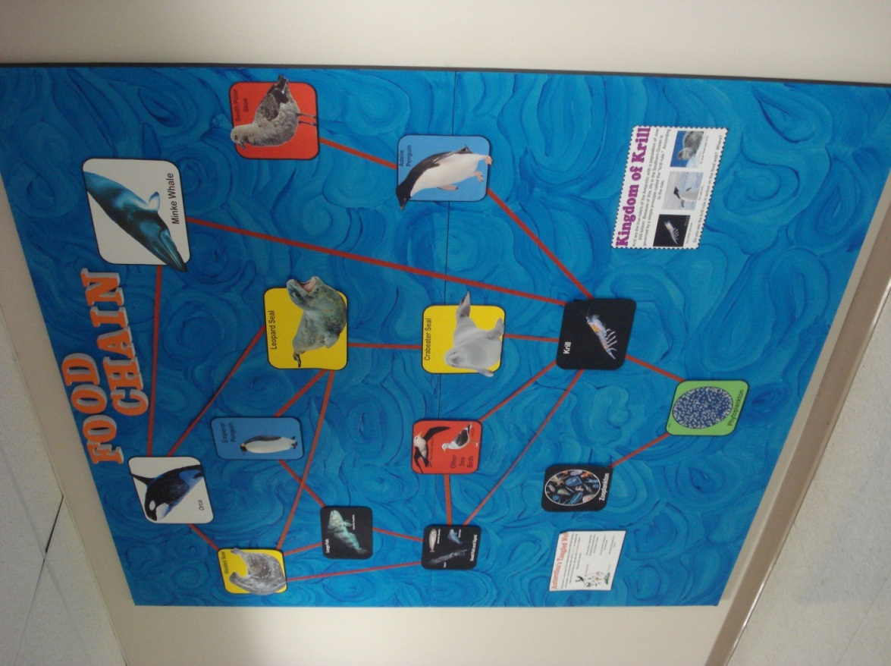
  - A food web is a visual map of the relationships between different animals in an ecosystem. Food webs always start with a producer, an organism that makes its food from the sun, and ends with consumers, animals that eat other animals.
  - This wall gives a glimpse into the amazing ecosystem that is in the Southern Ocean.
  - Can you find the producer in this food web?
  - How many consumers are there?
- Kingdom of Krill
  - Krill are the true rulers of the Antarctic with a population of over 600 billion! Because of this, life in the Southern Ocean is governed by a simple principle called the “krill rule.” According to the rule: You either are krill . . . You eat krill. . . Or your food eats krill.
  - Do you see the krill rule in action on the food web? Where?

Images:
- Phytoplankton
- Krill
- Small Fish and Squid (Squid, Antarctic Silverfish, Borch Fish)
- Large Fish (Antarctic Toothfish)
- South Polar Skua
- Other Sea Birds (Black Browed Albatross, Kelp Gull)
- Emperor Penguin
- Adélie Penguin
- Weddell Seal
- Crabeater Seal
- Leopard Seal
- Orca
- Minke Whale
- Zooplankton
Greetings From:
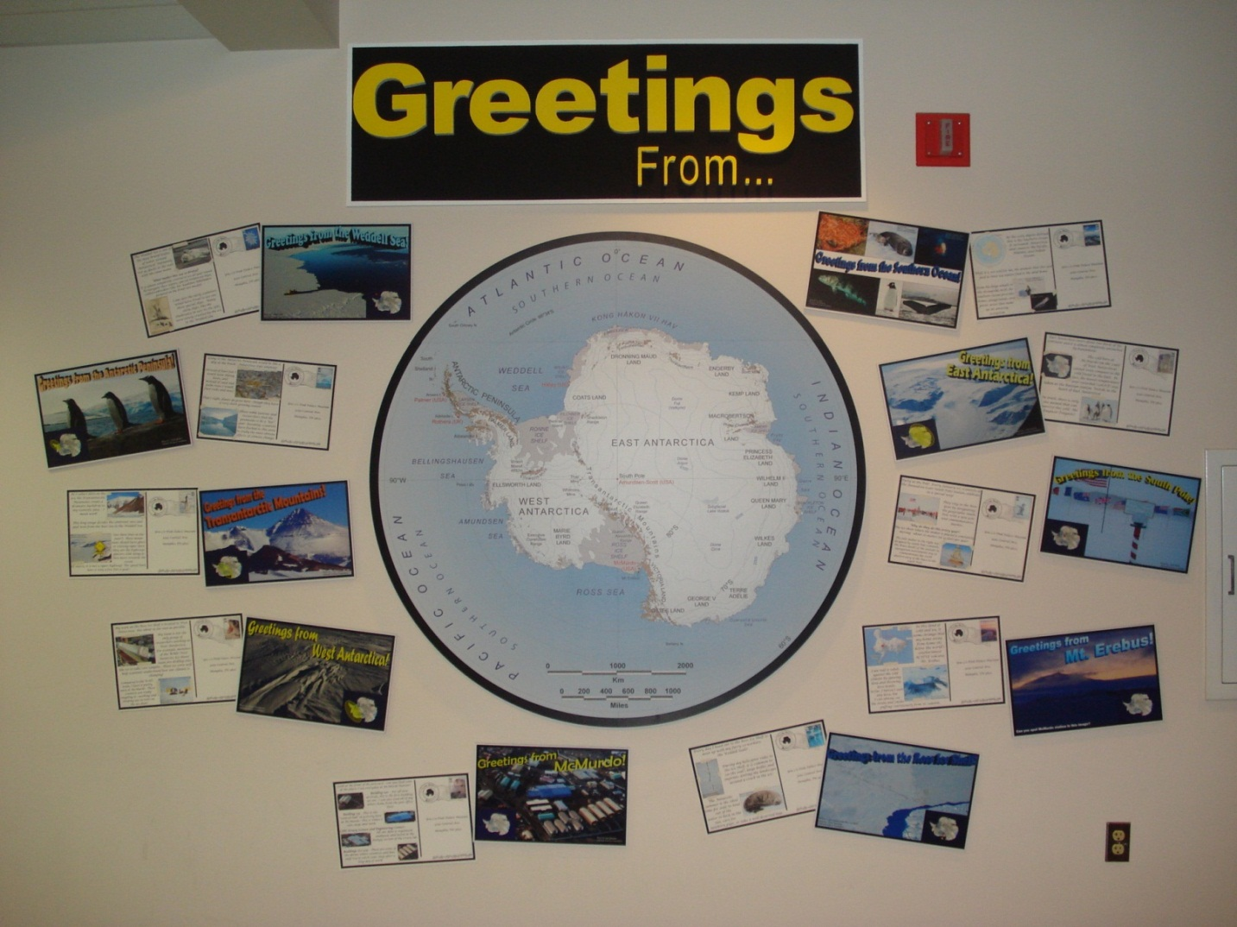
Antarctic Peninsula
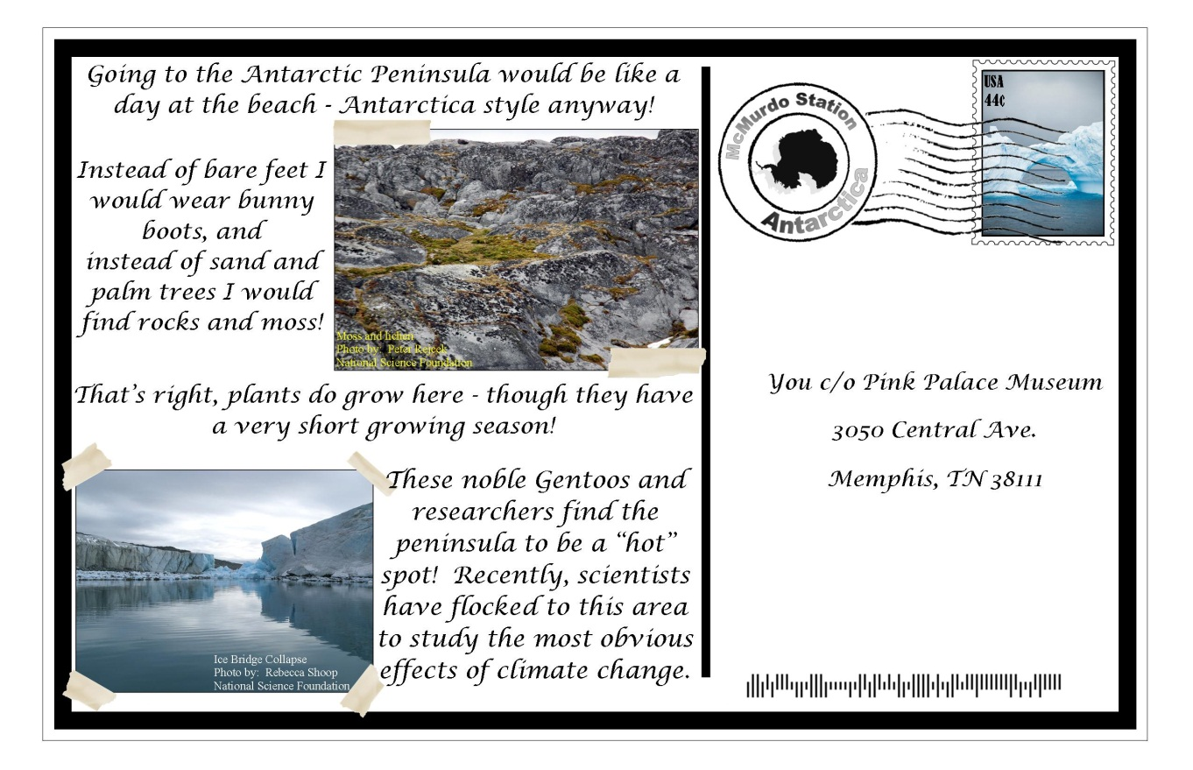

East Antarctica
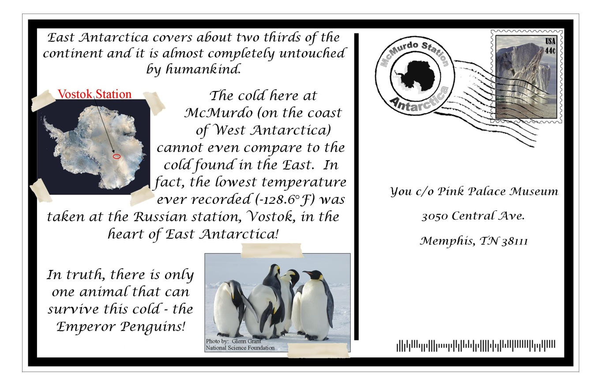

McMurdo Station

Mt. Erebus
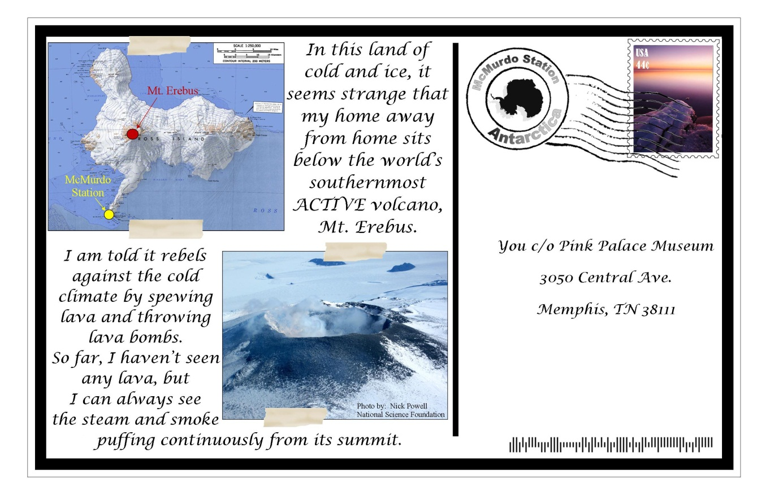

Ross Ice Shelf
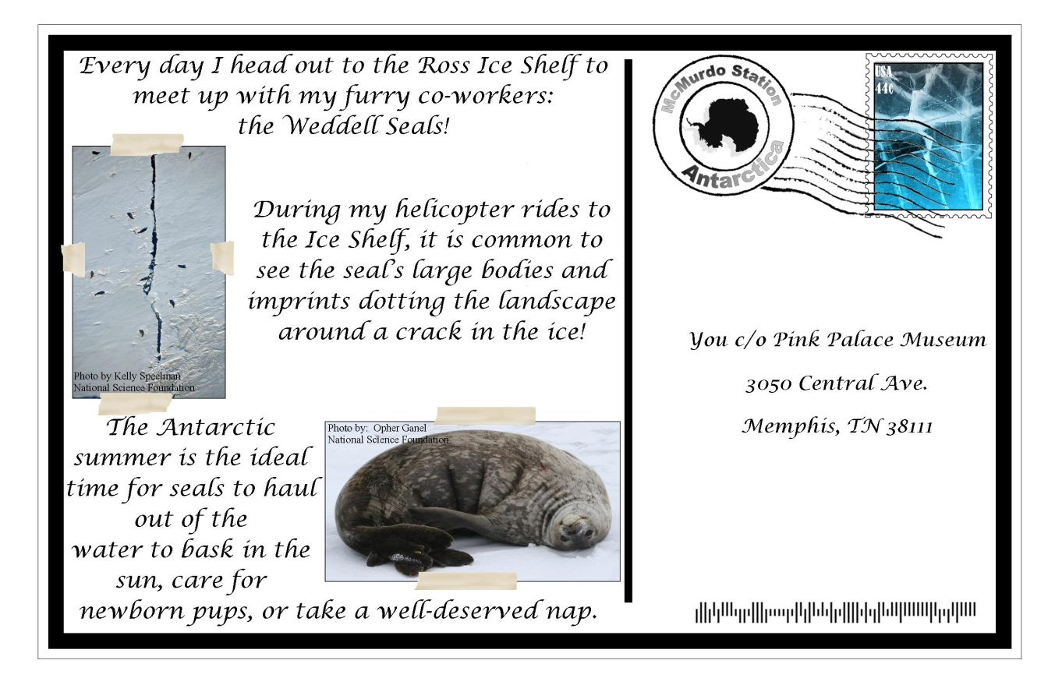

South Pole

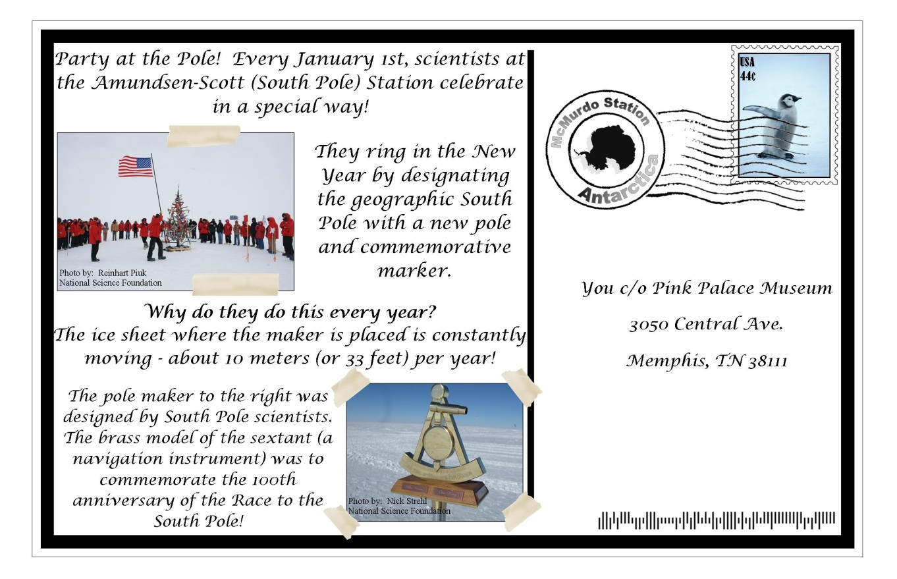

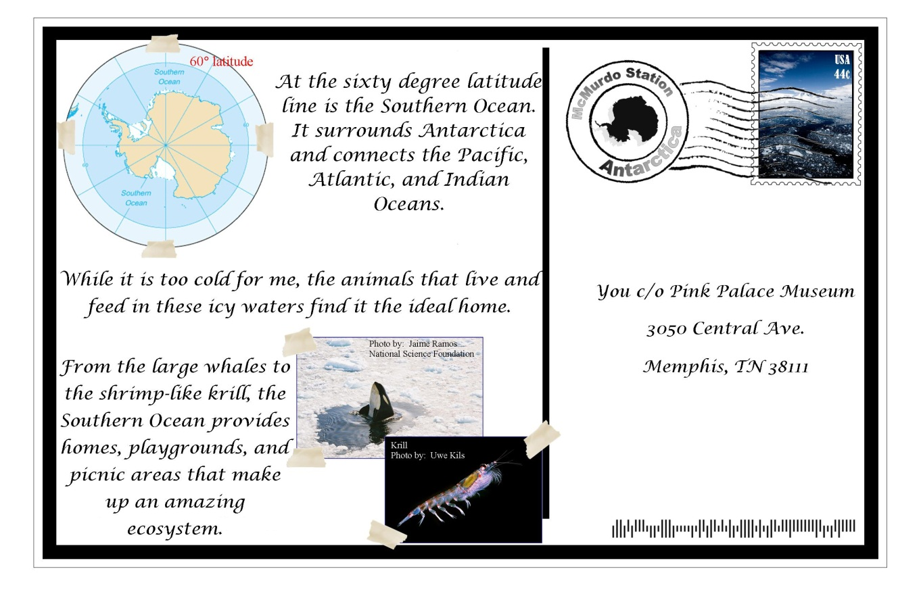
Southern Ocean
Transantarctic Mountains
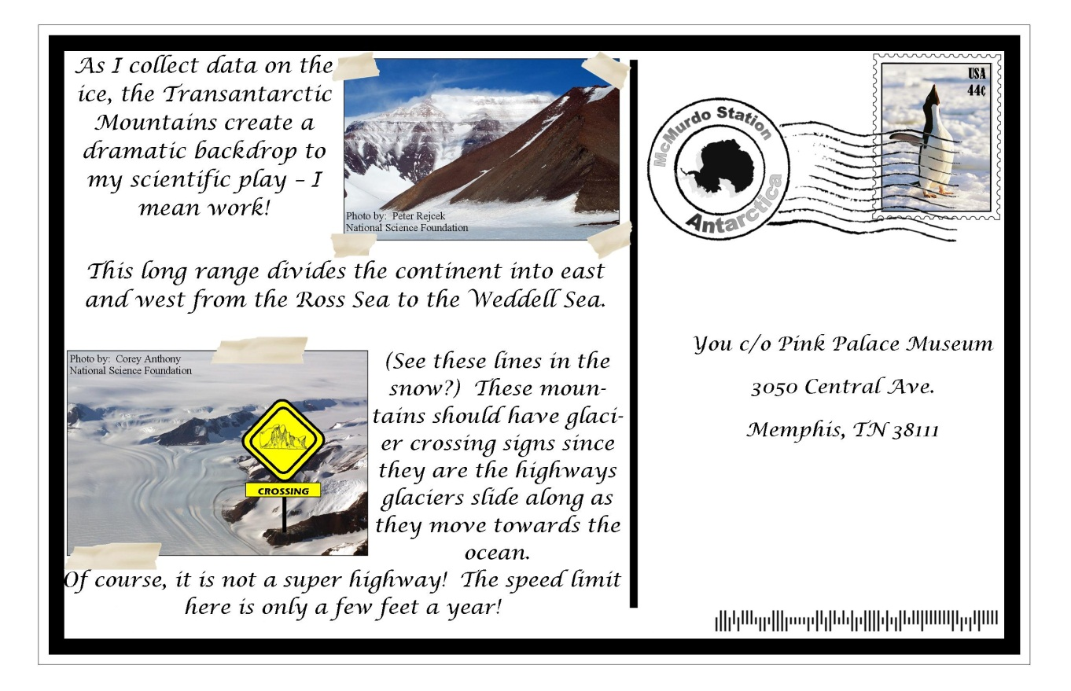
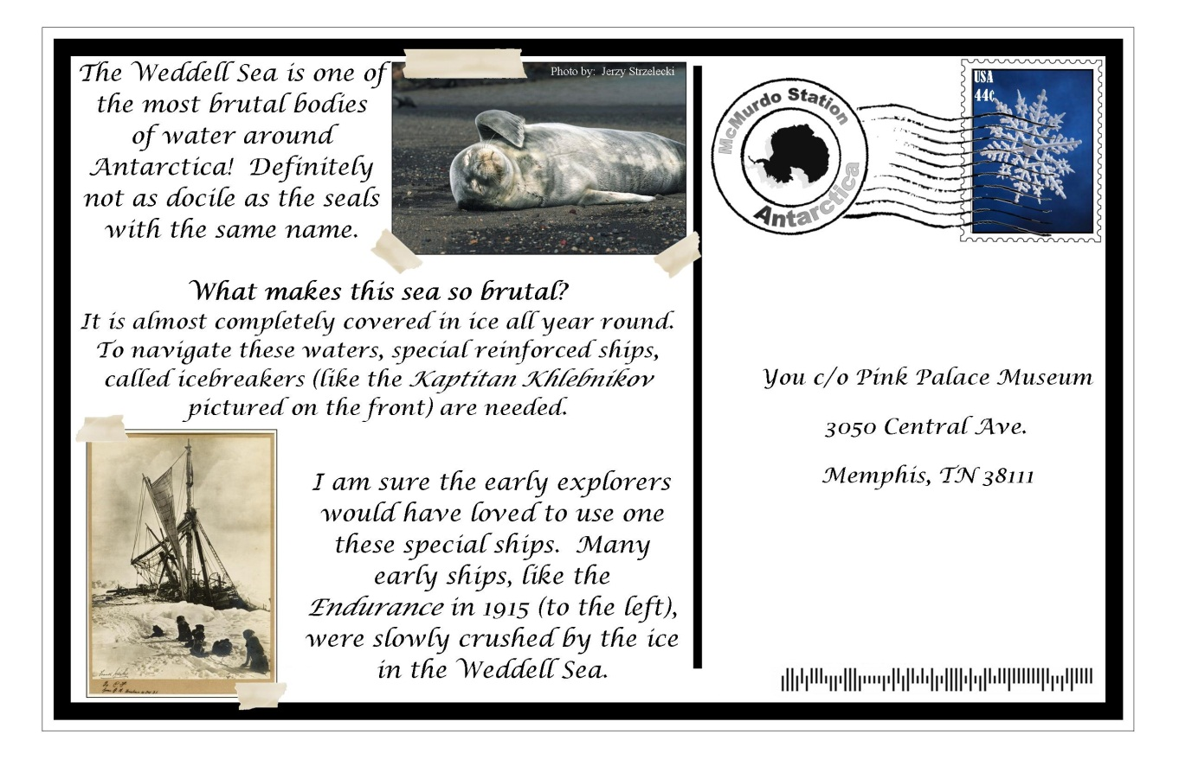
Weddell Sea

West Antarctica
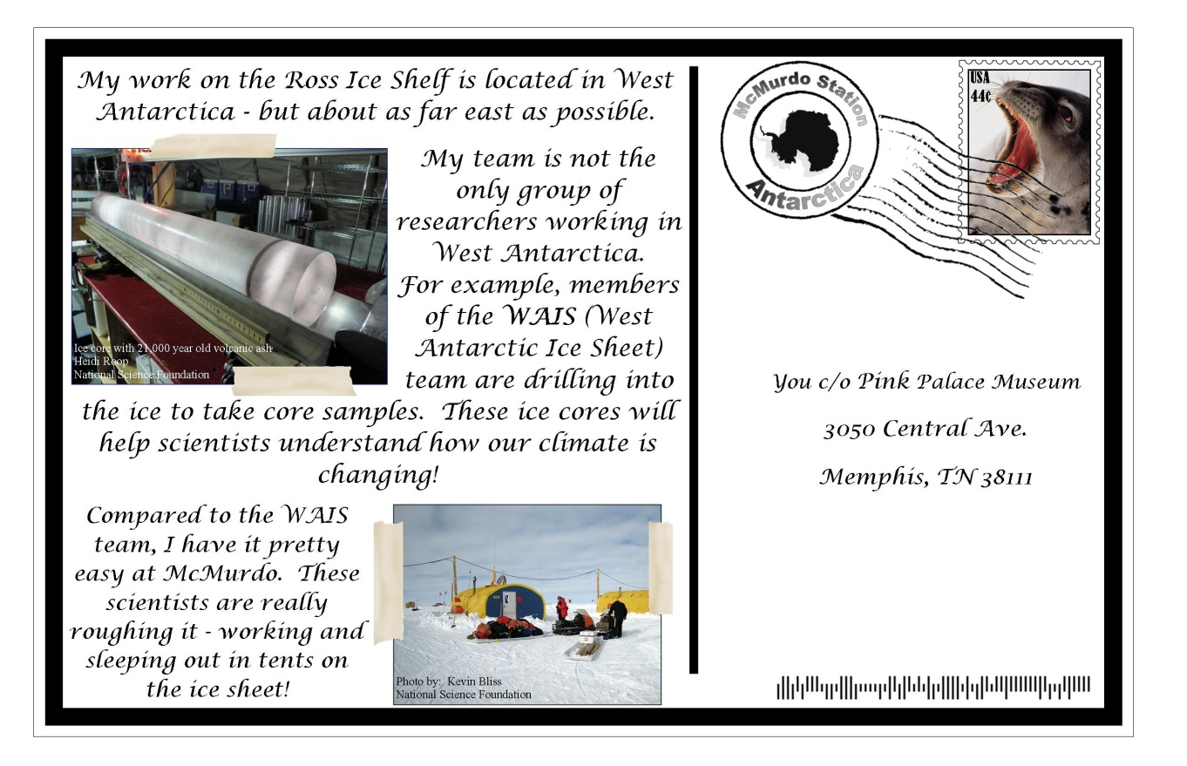

Extreme Antarctica:
