Bruce Taterka PolarTREC Professional Outreach Strategy
April 18, 2014

A. NSTA Boston 2014

1. I presented two talks at NSTA Boston in April 2014: one on my own and one in collaboration with Nell & Alicia (see attached).
2. Attended PEI mixer and discussed my PolarTREC experience.
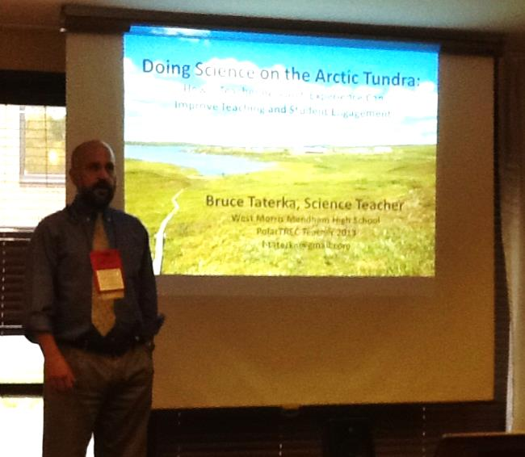
B. Other professional meetings

1. Presented a workshop on my PolarTREC experience at the NJ Science Teachers Convention in October 2013.

C. Brown Bag Lunch

1. I will hold a brown bag lunch for teachers at my school to report on my expedition and offer opportunities for collaboration.

D. Teacher Networks:

1. Earthwatch Fellows. I was an Earthwatch Fellow in 2009 and promoted my work through discussions and exchanging materials with them.
2. NOAA Teachers at Sea. I was a TAS in 2010 and keep in touch with teachers through that network. Promoted my work through discussions and exchanging materials with them.
3. US Department of Education Teaching Ambassador Fellows. I was a TAF in 2011-2012 and maintain active communication with that network. Promoted my work through discussions and exchanging materials with them.

E. Area Science Teachers

1. Served as mentor to two first-year AP Environmental Science teachers in New York City. Visited classroom in Brooklyn and shared PolarTREC pictures, presentations and other materials with them.

F. Publish Lesson Plans

1. I am working with Rose to create a manual of K-12 lab activities based on her work, so the lessons I create will be published in either a print or online manual that we are developing, rather than a professional magazine.

NSTA BOSTON 2014: Bruce
By engaging in opportunities for scientific research, policymaking, and community service teachers can improve their practice, expand professional networks and become leaders.

The path to teacher leadership requires stepping out of the classroom, but doesn’t require leaving it behind. Teachers can build leadership skills by taking advantage of local, national and international opportunities for engagement on many levels. Bruce Taterka will describe ways to get involved in three areas: scientific research, government policy, and local volunteerism, all of which can promote leadership capacity. Taterka’s path to teacher-leadership began as an after-school volunteer educator and citizen scientist for local environmental organizations. Based on that work, Taterka earned an Earthwatch Teacher Fellowship to work on a research expedition to the cloud forest of Ecuador, spent 3 weeks as a NOAA Teacher at Sea in the Gulf of Mexico during the BP Oil Spill, co-wrote New Jersey’s Environmental Literacy Plan, and served a full year as a U.S. Department of Education Teaching Ambassador Fellow and teacher-advisor to the NJ Department of Education. In the summer of 2013 Taterka spent 4 weeks on the Arctic tundra with a university expedition through the PolarTREC program. Taterka, who has remained a full-time teacher throughout, will discuss how these programs build capacity for teacher leadership, and will provide advice on how to how to get actively engaged.

NSTA BOSTON 2014: Alicia, Nell & Bruce
Teacher Research Experiences on the Arctic Tundra Through PolarTREC: Working and Collaborating at the Toolik Field Station
Abstract (150-200 words):
In the summer of 2013 the PolarTREC program sent three teachers on month-long expeditions to work with scientific research teams at the Toolik Field Station, located above the Arctic Circle in Alaska. Nell Kemp, who teaches middle-school science in Chicago, worked with a team from Duke University studying predatory spiders on the tundra. Alicia Gillean, a middle-school library media specialist from Jenks, Oklahoma, worked with University of Alaska scientists researching circadian rhythms in Arctic ground squirrels. Bruce Taterka, who teaches high-school science in Mendham, New Jersey, worked with researchers from the University North Carolina and Michigan studying the fate of organic carbon in melting permafrost. The PolarTREC experience allowed us to improve our content knowledge on polar ecology, immersed us in field and laboratory techniques, and provided a deep understanding of the process of science. As PolarTREC teachers we have embarked on science outreach, engaging our students and communities in discussions on science (including climate science), through face-to-face and multimedia efforts. Participating in teacher-research with PolarTREC enabled us to bring cutting-edge science into our school environments and to make distant but strong professional connections to support our teaching and professional development.

